Wireless Weather Station Technical Manual
Release 1.0

Document Control
Item | Value
Document Title | Wireless Weather Station Technical Manual
Document ID | WWS-TM-001
Revision | 1.0
Status | Release
Author | Jim
Classification | Technical Reference
System Version | Release 1 Platform

Revision History
Revision | Date | Description
0.1 | Initial Development | Original weather station concept
0.5 | Development Phase | Multi-controller architecture established
0.6 | Development Phase | LoRa communications implemented
0.7 | Development Phase | Solar-powered outdoor node added
0.8 | Development Phase | Remote reboot and uptime monitoring added
0.9 | Development Phase | Dashboard and database architecture expanded
1.0 | October 2026 | Initial technical manual release

Acronyms and Definitions
Acronym | Definition
ADC | Analog-to-Digital Converter
BMP280 | Bosch Barometric Pressure Sensor
DS3231 | Real-Time Clock Module
EEPROM | Electrically Erasable Programmable Read-Only Memory
ESP32 | Espressif 32-bit Microcontroller
GPIO | General Purpose Input / Output
HTTP | Hypertext Transfer Protocol
I²C | Inter-Integrated Circuit
LCD | Liquid Crystal Display
LoRa | Long Range Radio
RTC | Real-Time Clock
SHT31-D | Temperature/Humidity Sensor
UART | Universal Asynchronous Receiver / Transmitter
WU | Weather Underground

List of Figures
Figure | Description
3-1 | System Architecture Diagram
4-1 | Indoor Electronics Diagram
4-2 | Outdoor Electronics Diagram
4-3 | Solar Power System
4-4 | I²C Sensor Bus Diagram
4-6 | Indoor Controller Assembly
4-7 | Outdoor Sensor Mast
4-8 | Radiation Shield Installation
6-1 | Dashboard Data Flow
8-1 | Communications and Data Acquisition Architecture
10-1 | Dashboard Screenshot
11-1 | Environmental Processing Pipeline
11-2 | Temperature Suppression Curve
11-3 | Dew Point Calculation Flow
12-1 | Outdoor Sensor Mast Installation
12-2 | Radiation Shield Installation
13-1 | Troubleshooting Workflow
14-1 | Annual Maintenance Verification Flow
15-1 | Cold Start Initialization Sequence

List of Tables
Table | Description
3-1 | Controller Responsibility Matrix
4-1 | Indoor Hardware Inventory
4-2 | Outdoor Hardware Inventory
4-3 | Arduino Mega GPIO Assignments
4-4 | ESP32-S3 GPIO Assignments
4-5 | ESP32-C3 GPIO Assignments
4-6 | Sensor Wiring Summary
4-7 | Solar Power Components

Section 1 – Introduction
1.1 Purpose
This manual documents the design, architecture, operation, maintenance, and future development of the Wireless Weather Station system.
The system combines environmental sensing, local monitoring, wireless telemetry, Internet connectivity, database storage, and dashboard presentation into a fully integrated weather-monitoring platform.
The document is intended to serve as the primary engineering reference for:
- Construction
- Maintenance
- Troubleshooting
- Firmware modification
- Future expansion

1.2 System Description
The weather station is built around a distributed architecture based on three cooperating controllers:
Arduino Mega
The Arduino Mega functions as the primary supervisory controller.
Responsibilities include:
- User interface management
- Sensor integration
- EEPROM management
- RTC management
- Min/max tracking
- Outdoor-node supervision
- Data aggregation
ESP32-S3 Gateway
The ESP32-S3 serves as the Internet gateway and presentation platform.
Responsibilities include:
- Dashboard hosting
- Wi-Fi communications
- Database uploads
- Weather Underground uploads
- Status monitoring
ESP32-C3 Outdoor Node
The ESP32-C3 serves as the outdoor telemetry controller.
Responsibilities include:
- Wind-speed measurement
- Wind-direction processing
- Rainfall measurement
- LoRa communications
- Outdoor uptime tracking

1.3 Design Goals
The weather station was designed around several key objectives:
Reliability
The station must continue operating through temporary communications failures and Internet outages.
Serviceability
The system should be diagnosable without specialized equipment.
Modularity
Major subsystems must be replaceable independently.
Expandability
Future sensors and capabilities should be incorporated without redesigning the architecture.
Data Integrity
Weather observations and system status information must be preserved for analysis and long-term review.

1.4 Major Features
The current system provides:
- Temperature monitoring
- Relative humidity monitoring
- Dew-point calculation
- Barometric pressure measurement
- Wind-speed measurement
- Wind-gust measurement
- Wind-direction measurement
- Rainfall measurement
- Historical data storage
- Browser-based dashboard
- Weather Underground integration
- Automatic fault recovery
- Solar-powered outdoor operation

Section 2 – System Overview
2.1 System Functions
The station performs four major functions:
Measure
Transmit
Display
Archive
Environmental data is acquired from indoor and outdoor sensors, transmitted through internal communications links, displayed locally and remotely, and archived within a database.

2.2 Environmental Measurements
The station currently measures:
Parameter | Source
Temperature | SHT31-D / BMP280
Humidity | SHT31-D
Dew Point | Calculated
Pressure | BMP280
Wind Speed | Anemometer
Wind Gust | Anemometer
Wind Direction | Wind Vane
Rainfall Rate | Rain Gauge
Daily Rainfall | Rain Gauge
Outdoor Uptime | ESP32-C3

2.3 Data Path
Environmental measurements traverse the following path:
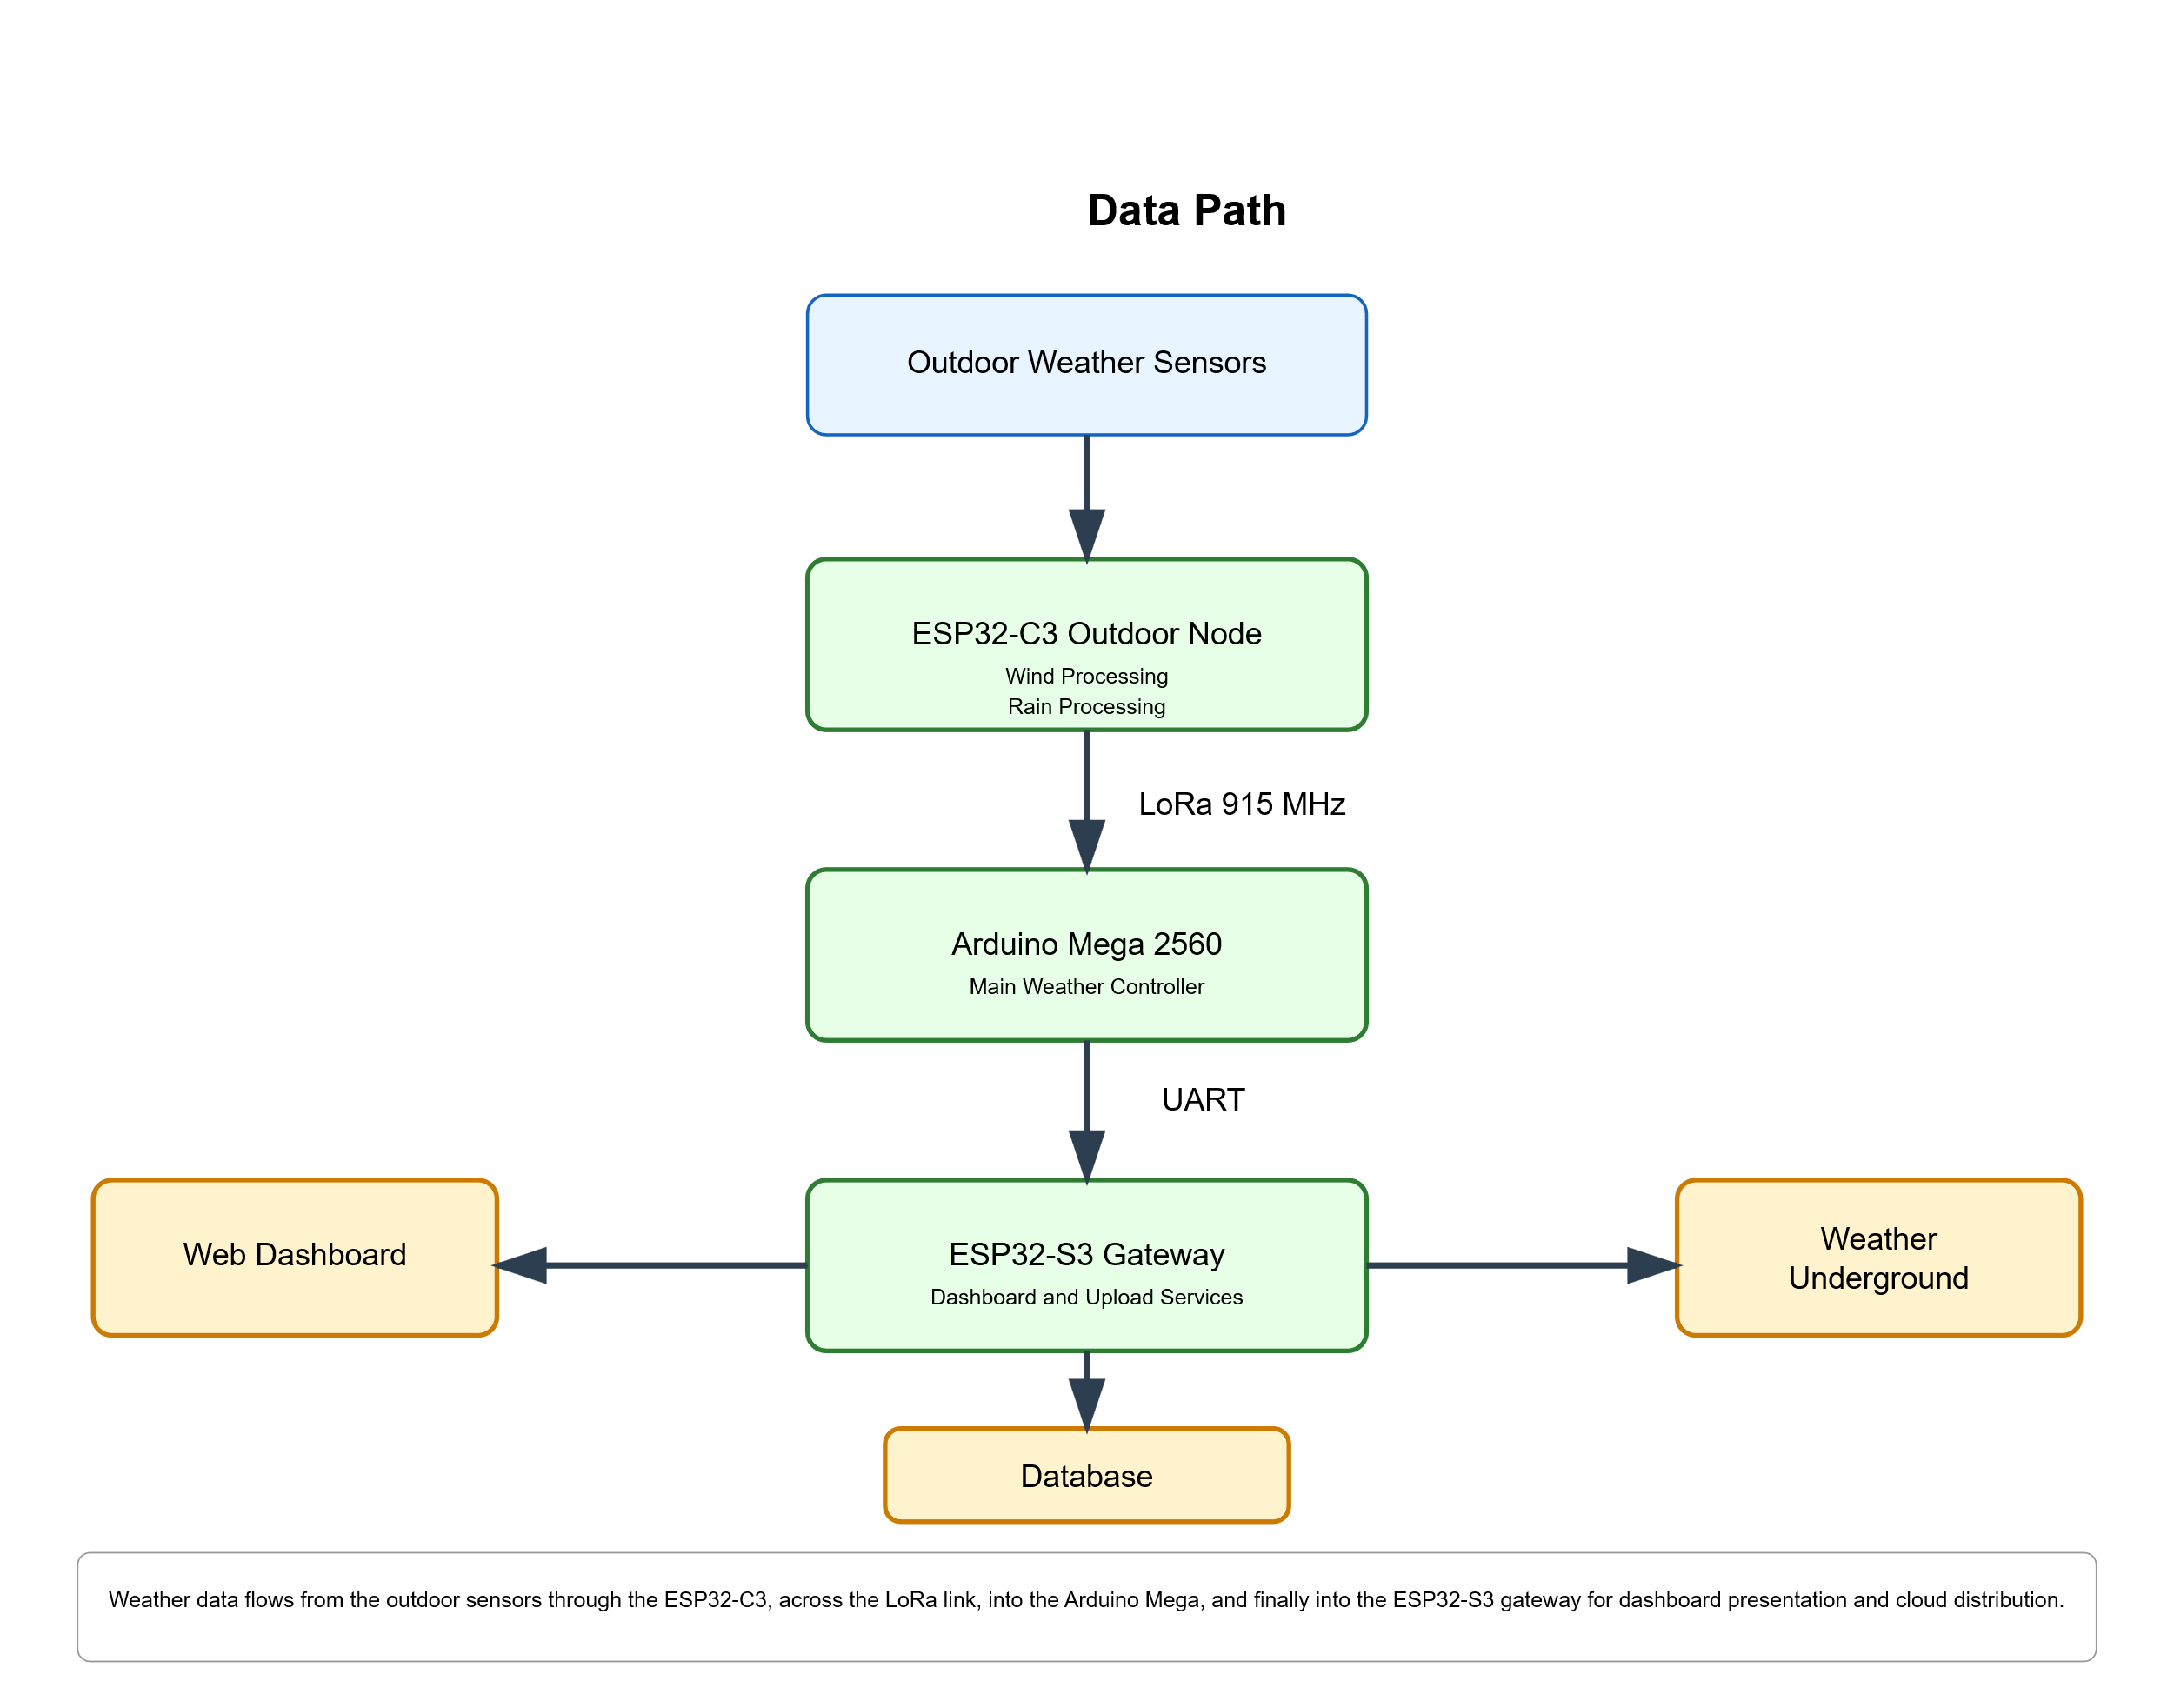
This architecture separates measurement from presentation and storage.

2.4 Operational Cycle
The normal operating cycle is:
- Outdoor node acquires measurements.
- Outdoor node transmits LoRa packet.
- Arduino Mega parses telemetry.
- Arduino Mega combines indoor and outdoor data.
- Mega generates weather packet.
- ESP32-S3 receives packet.
- Dashboard updated.
- Database updated.
- Weather Underground updated.
The cycle typically repeats every five seconds.

Section 3 – System Architecture
3.1 Architectural Overview
The weather station utilizes a three-controller distributed architecture.
This design distributes responsibilities across specialized controllers rather than placing all functions on a single device.
Advantages include:
- Improved reliability
- Lower software complexity
- Easier debugging
- Improved scalability

Figure 3-1. System Architecture Diagram
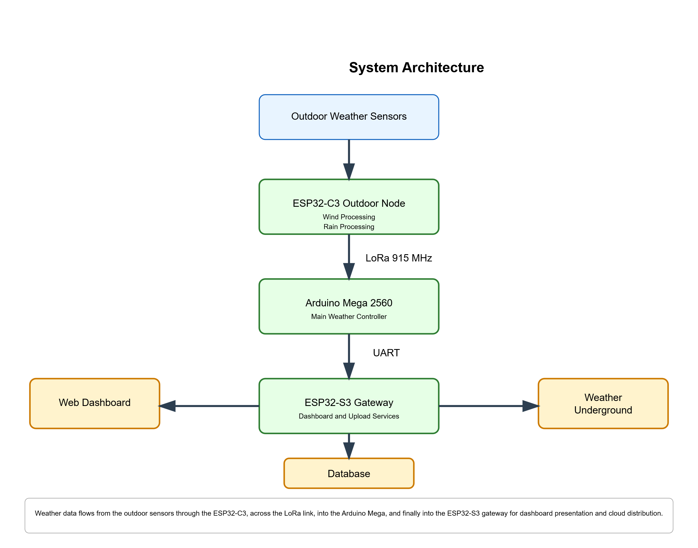

3.2 Controller Responsibility Matrix
Controller | Primary Responsibilities
Arduino Mega | User interface, sensing, recovery management
ESP32-S3 | Dashboard, Wi-Fi, uploads
ESP32-C3 | Outdoor measurements and telemetry

3.3 Indoor Controller Architecture
The indoor controller subsystem consists of:
- Arduino Mega
- LCD Keypad Shield
- SHT31-D
- BMP280
- DS3231 RTC
- LoRa Module
- ESP32-S3
The Mega acts as the central authority for environmental processing and operational management.

3.4 Outdoor Controller Architecture
The outdoor subsystem contains:
- ESP32-C3
- LoRa module
- Wind vane
- Anemometer
- Rain gauge
- Solar power subsystem
This subsystem operates autonomously and transmits weather observations to the indoor station.

3.5 Fault Tolerance
The architecture contains multiple layers of fault tolerance:
Sensor Redundancy
Temperature can be obtained from multiple sources.
Communications Monitoring
LoRa communication health is continuously monitored.
Automatic Recovery
The Mega can command remote reboots of the outdoor node.
Dashboard Visibility
System health information is continuously available for diagnostics.

Section 4 – Hardware Overview
4.1 Hardware Architecture
The weather station hardware is divided into:
Indoor Hardware
Outdoor Hardware
Power System
Communications System

Figure 4-4. I²C Sensor Bus Diagram
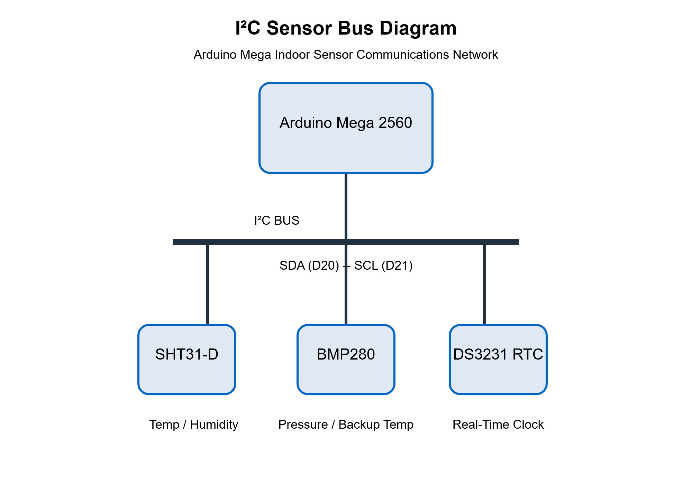
Indoor sensor communications bus showing the Arduino Mega,
SHT31-D temperature/humidity sensor, BMP280 pressure sensor,
and DS3231 real-time clock connected through the shared I²C
interface using SDA (D20) and SCL (D21).

4.2 Indoor Hardware Inventory
Component | Function
Arduino Mega 2560 | Main controller
LCD Keypad Shield | Local interface
SHT31-D | Temperature/Humidity
BMP280 | Pressure
DS3231 RTC | Timekeeping
RYLR890 | LoRa communications
ESP32-S3 | Gateway controller

Figure 4-1. Indoor Electronics Diagram
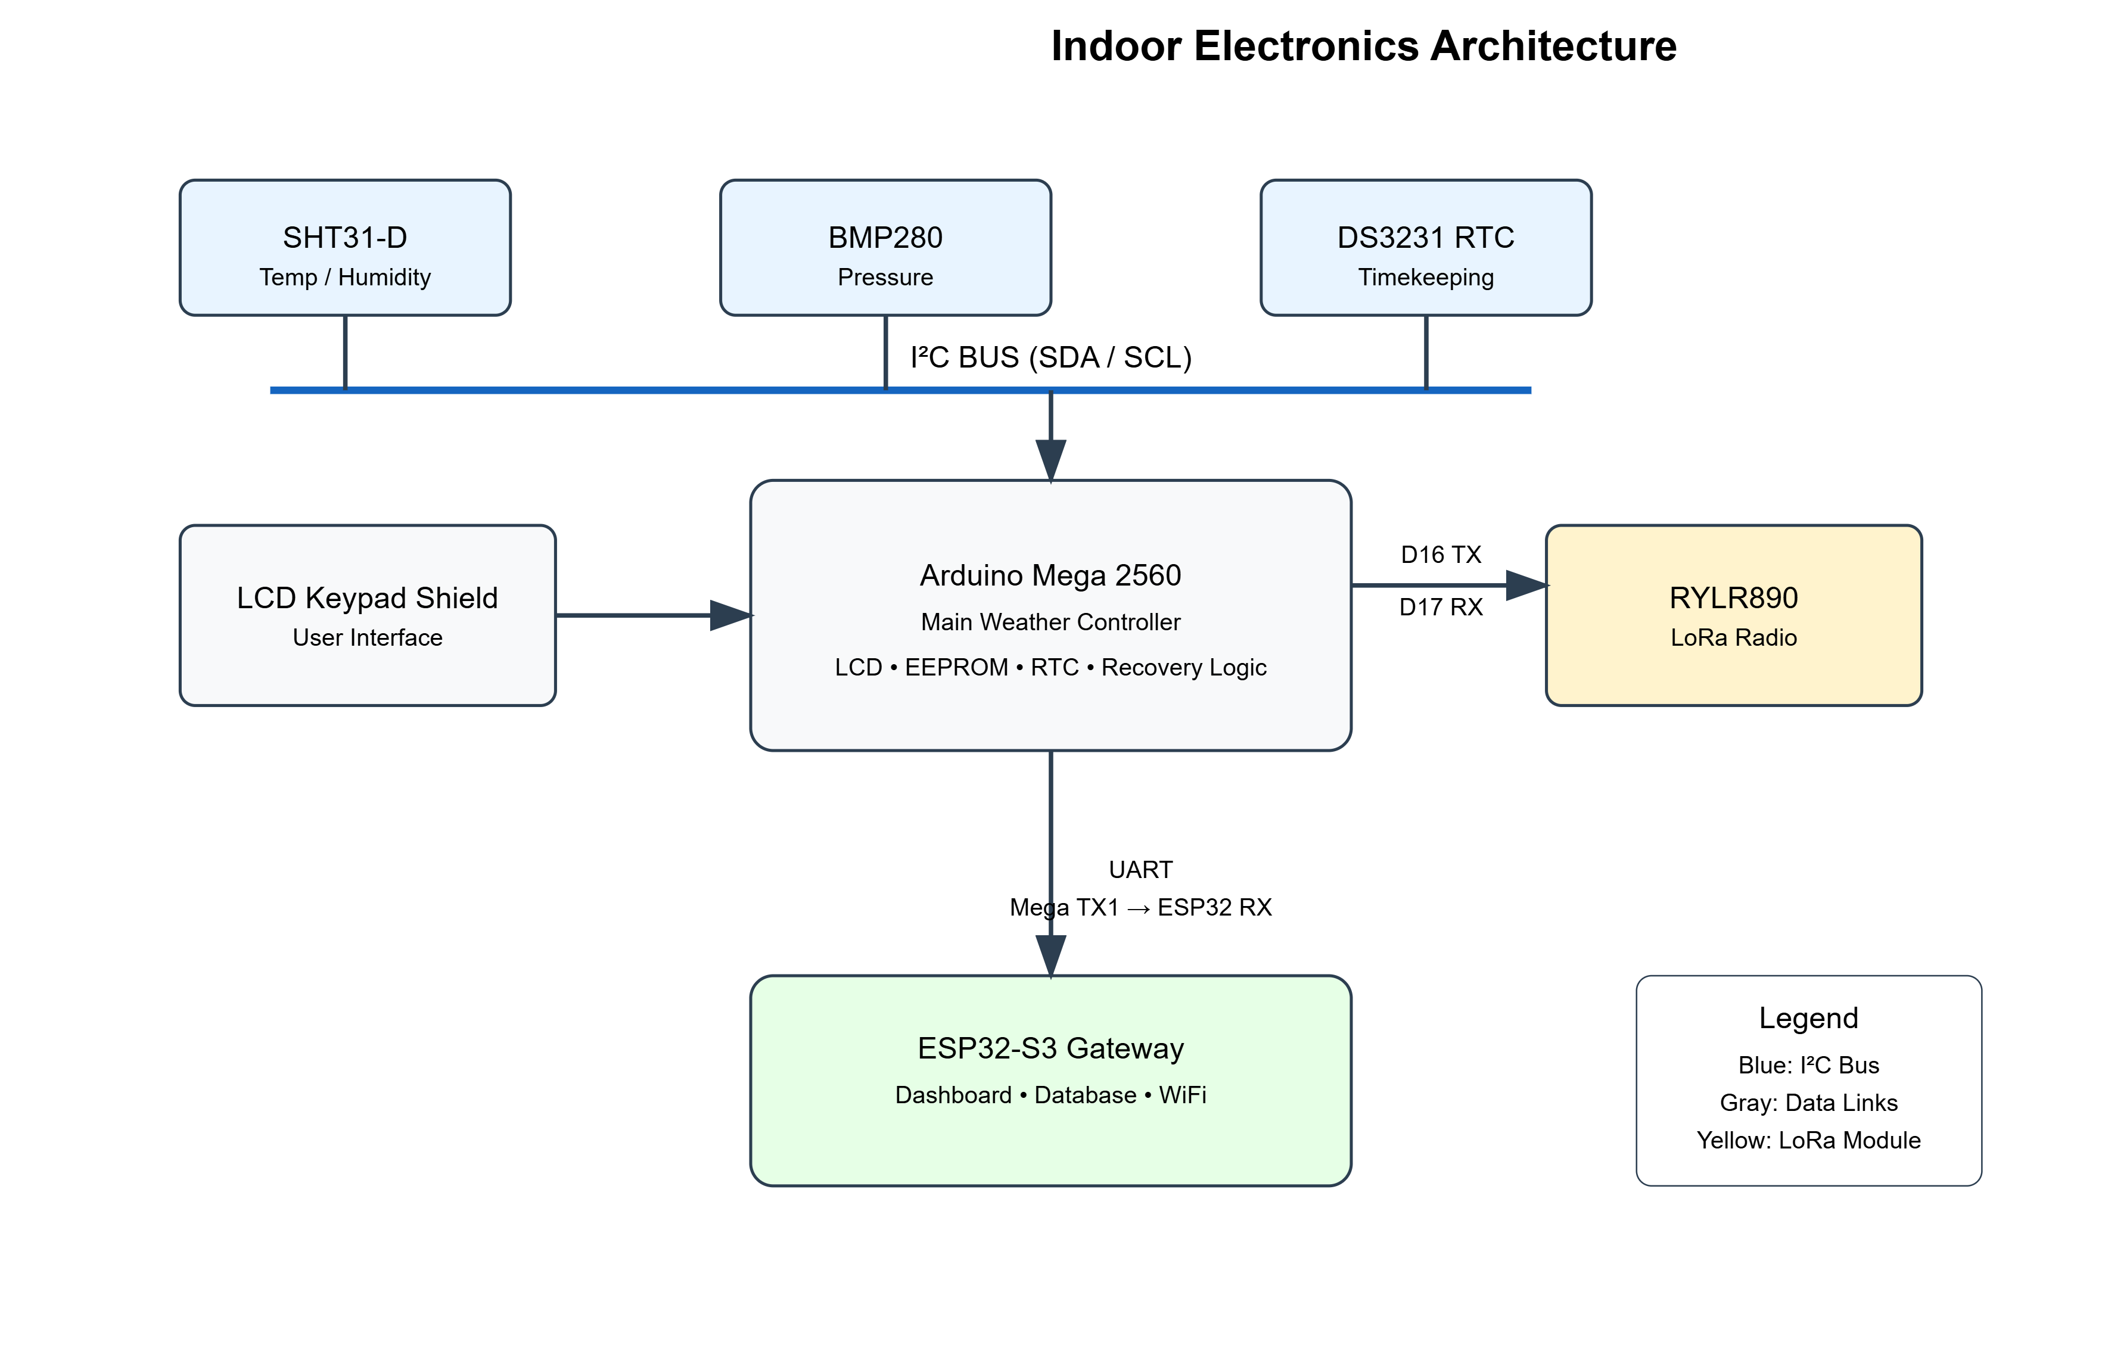
Figure 4-6. Indoor Controller Assembly
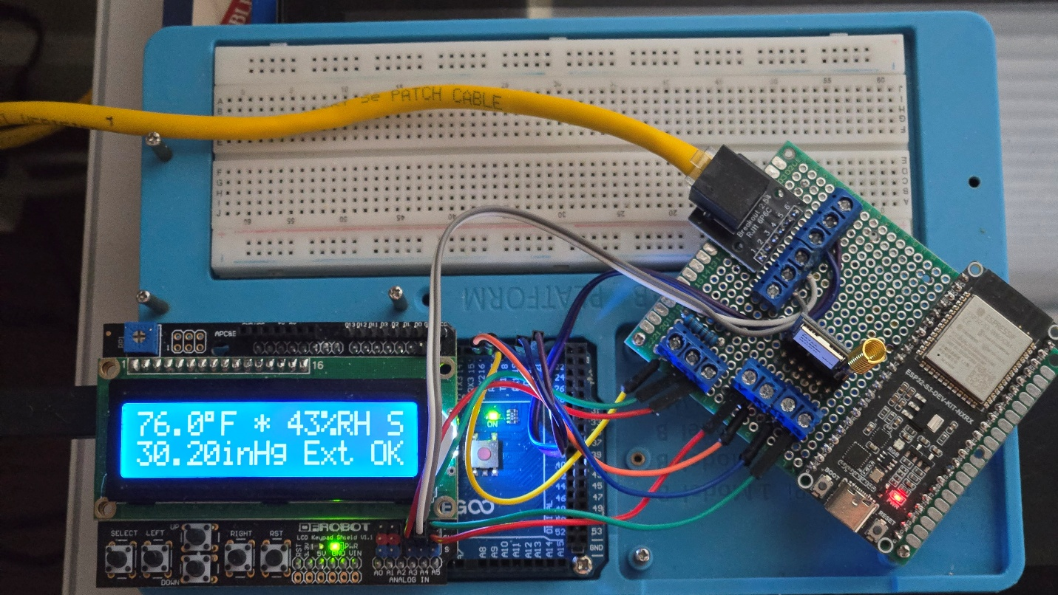Indoor electronics assembly showing Arduino Mega, sensors, LoRa transceiver, and ESP32-S3 gateway.

4.3 Outdoor Hardware Inventory
Component | Function
ESP32-C3 | Outdoor controller
Wind Vane | Direction sensing
Anemometer | Wind-speed sensing
Rain Gauge | Rainfall measurement
RYLR890 | LoRa communications
Antenna | RF communications

Figure 4-2. Outdoor Electronics Diagram
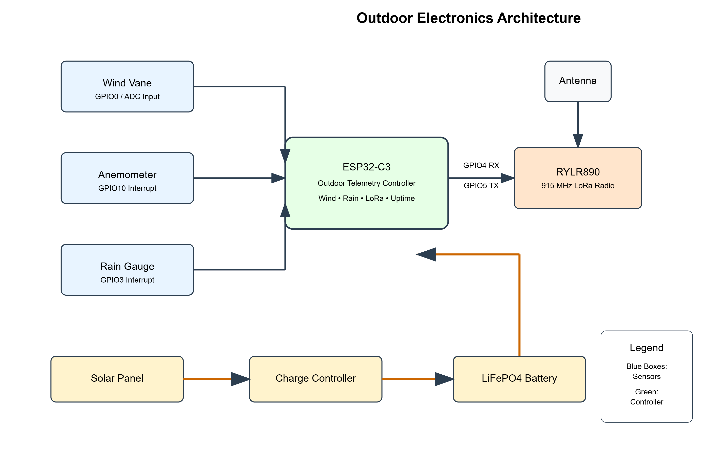

Figure 4-7. Outdoor Sensor Mast
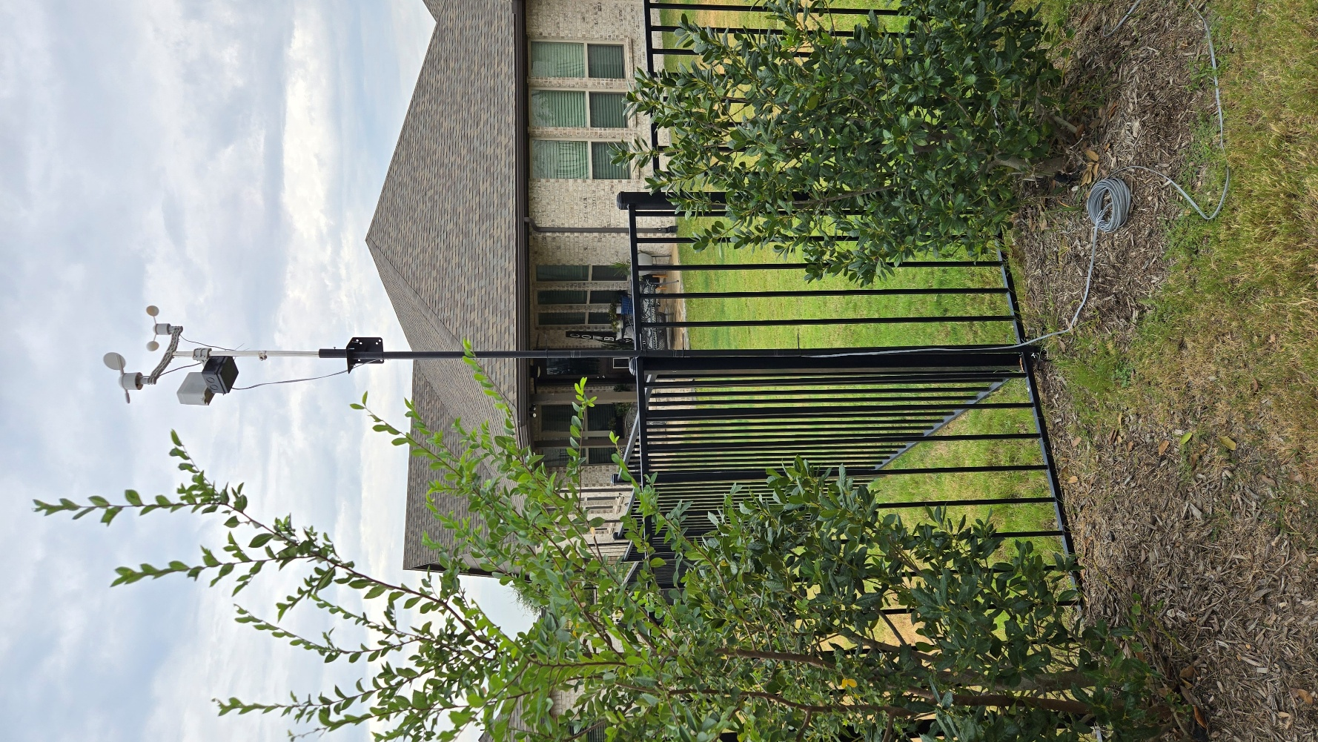
Outdoor sensor mast showing weather sensors and supporting hardware.

4.4 Arduino Mega GPIO Assignments
Pin | Function
A0 | LCD keypad input
D10 | LCD backlight
D16 | LoRa TX
D17 | LoRa RX
D18 | ESP32-S3 UART TX
D20 | SDA
D21 | SCL

4.5 ESP32-S3 GPIO Assignments
GPIO | Function
GPIO18 | UART RX
GPIO17 | UART TX

4.6 ESP32-C3 GPIO Assignments
GPIO | Function
GPIO10 | Anemometer
GPIO3 | Rain Gauge
GPIO0 | Wind Vane ADC
GPIO4 | LoRa RX
GPIO5 | LoRa TX

4.7 Sensor Wiring Summary
Wind Vane
Connection | Signal
Pin 2 | Ground
Pin 3 | 3.3V
Pin 5 | ADC
Anemometer
Connection | Signal
Pin 3 | GPIO10
Pin 4 | Ground
Rain Gauge
Connection | Signal
Pin 3 | GPIO3
Pin 4 | Ground

Signal Conditioning Components
Signal | ESP32-C3 Pin | Conditioning Circuit
Wind Vane | GPIO0 (ADC) | 12K pull-up resistor to 3.3V
Rain Gauge | GPIO3 | 10K pull-up resistor to 3.3V
Anemometer | GPIO10 | Direct digital input

A 12K pull-up resistor was selected to optimize ADC separation between vane resistor-network states.

Figure 4-3. Solar Power System
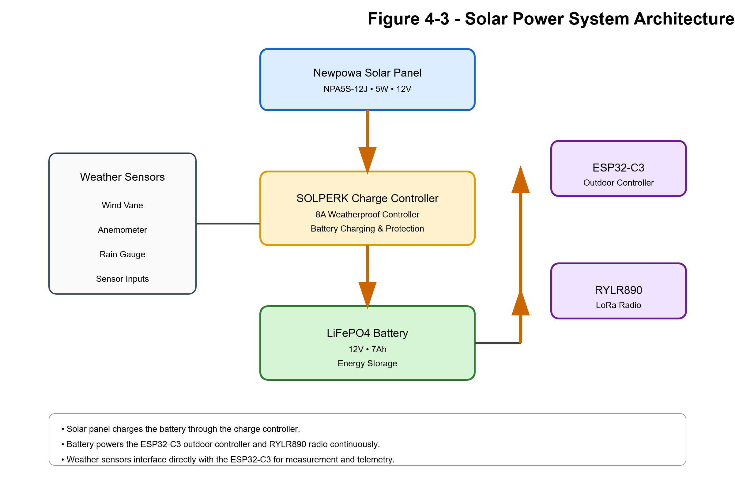

Table 4-7 Solar Hardware Inventory
Component | Manufacturer | Model | Specification | Purpose
Solar Panel | Newpowa | NPA5S-12J | 5W, 12V Monocrystalline | Primary energy source
Charge Controller | SOLPERK | 8A Controller | IP67 Rated | Battery charging and protection
Battery | WOXABHSL | LFP1207 | 12V 7Ah LiFePO4 | Energy storage
Outdoor Controller | ESP32-C3 | N/A | 3.3V Controller | Outdoor telemetry processing
LoRa Radio | Reyax | RYLR890 | 915 MHz | Wireless communications
Antenna | Compatible 915 MHz | N/A | LoRa antenna | Radio communications

Outdoor System Power Flow

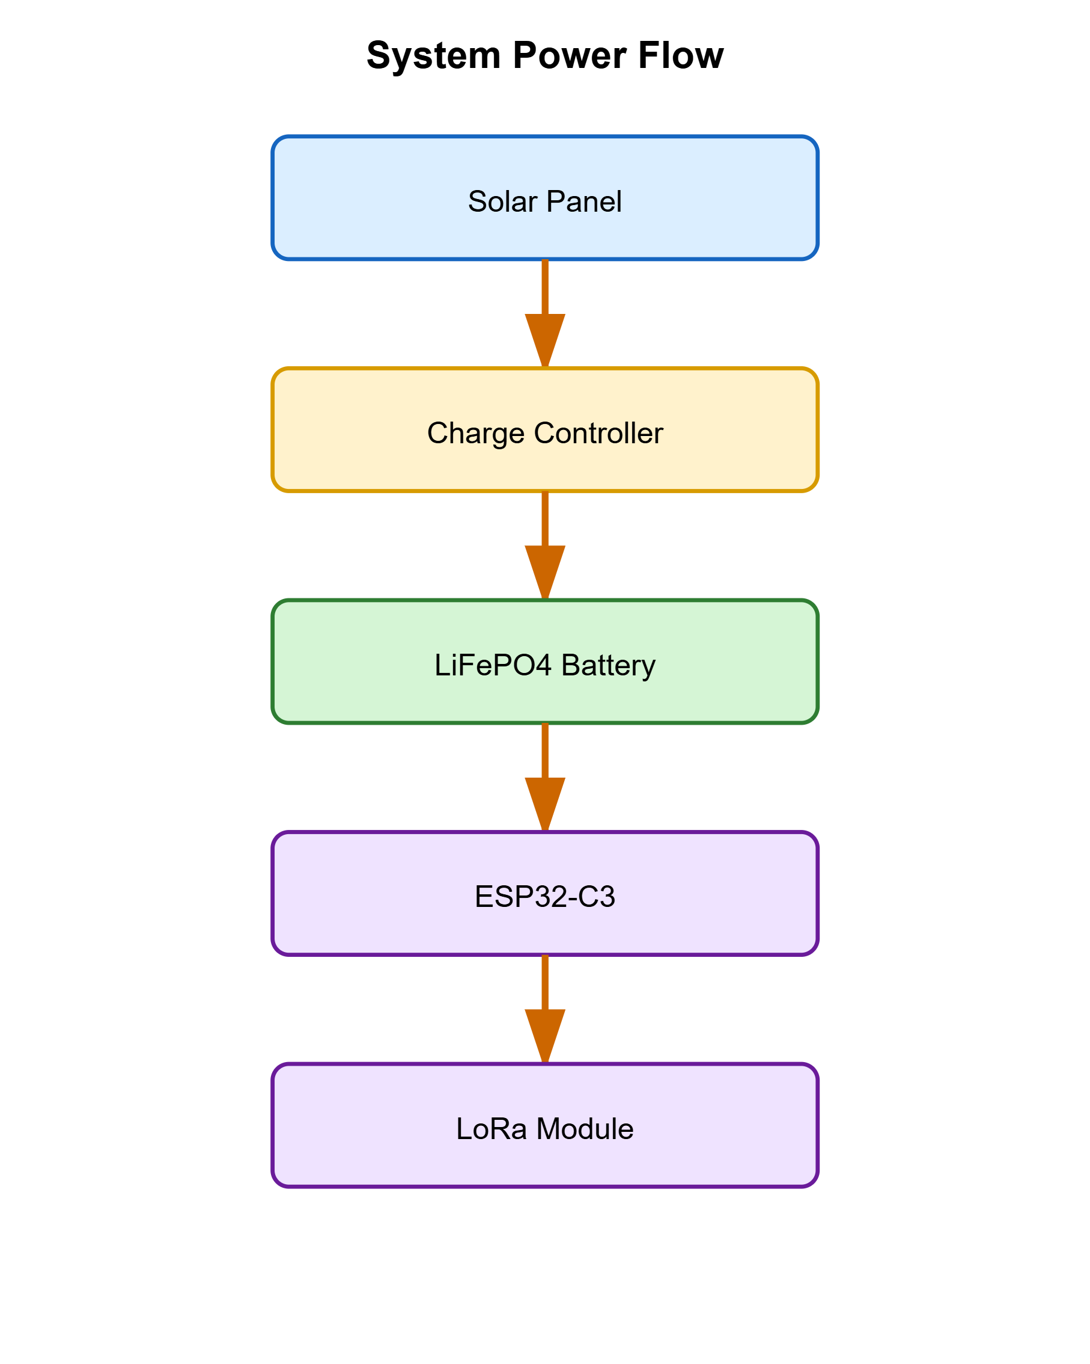
Design Objectives
The solar-power subsystem was selected to provide:
- Continuous outdoor operation
- No external power wiring
- Flexible sensor placement
- Improved installation options
- Reduced maintenance requirements
The battery and charge controller are sized to maintain operation during periods of reduced solar availability while supporting continuous weather monitoring and LoRa communications.

Figure 4-8. Radiation Shield Installation
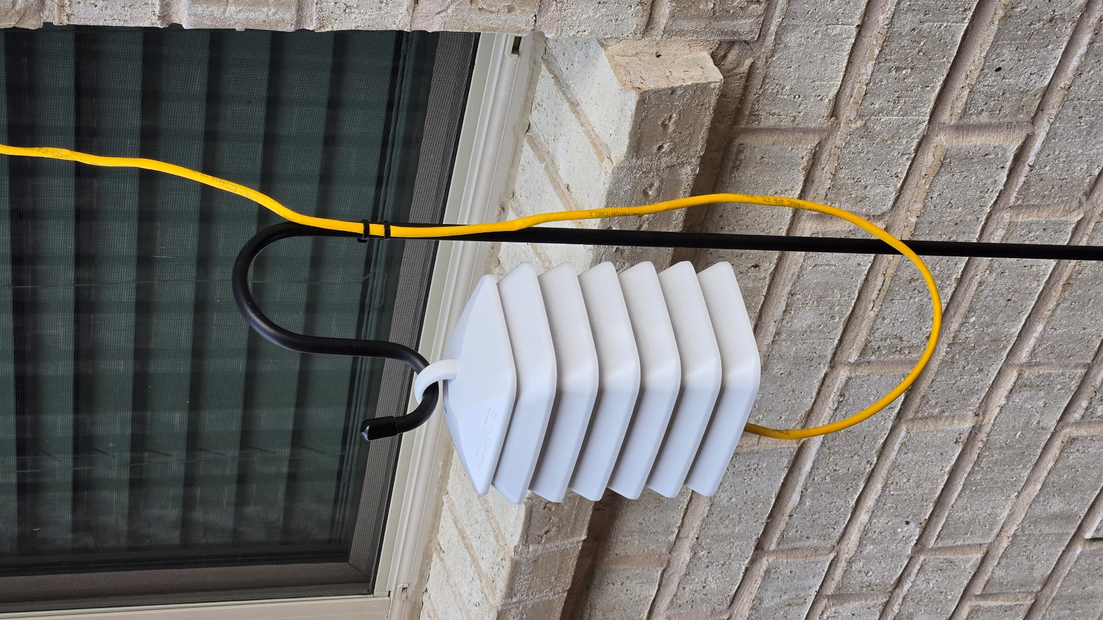
Radiation shield used for temperature and humidity measurements.

4.9 Communications Hardware
The communications subsystem consists of:
- LoRa indoor module
- LoRa outdoor module
- LoRa antennas
- UART interface
- Wi-Fi interface
These components provide all data transport throughout the system.

Sections 5–8
Firmware Architecture and Communications

Section 5 – Arduino Mega Firmware Architecture
5.1 Purpose
The Arduino Mega serves as the central supervisory controller for the weather station. While the outdoor ESP32-C3 acquires weather measurements and the ESP32-S3 provides network and dashboard services, the Mega functions as the operational core of the system.
Responsibilities include:
- User-interface management
- Environmental sensor processing
- RTC management
- EEPROM management
- Min/max record tracking
- Outdoor-node supervision
- Weather-data aggregation
- Communications coordination
- Fault-recovery management
The Mega is therefore the primary authority for weather-system state and operational control.

5.2 Software Architecture
The firmware utilizes a cooperative multitasking model built around the Arduino loop() function.
Rather than relying on a real-time operating system, the firmware schedules periodic activities through millisecond timing intervals using:
C++
millis()
This approach allows multiple independent activities to operate concurrently without blocking user interaction.
Major tasks include:

Sensor Acquisition
LCD Updates
Button Monitoring
LoRa Reception
ESP32 Packet Generation
EEPROM Management
Min/Max Tracking
Recovery Management
Diagnostics

5.3 User Interface Architecture
LCD Hardware
The user interface utilizes a standard LCD Keypad Shield mounted directly on the Arduino Mega.
The shield provides:
- 16x2 LCD display
- Five navigation buttons
- Backlight control
Buttons are connected through a resistor ladder network monitored on analog input A0.

Button Functions
Button | Function
RIGHT | Navigate Forward
LEFT | Navigate Back
UP | Value Increase / Menu Navigation
DOWN | Value Decrease / Menu Navigation
SELECT | Accept / Enter

Menu Structure
The firmware implements a hierarchical menu system.
Primary screens:

Super Screen
Wind Screen
Rain Screen
Clock Screen
Pressure Screen
Min Temperature
Max Temperature
Humidity Records
Pressure Records
Settings
Diagnostics
Button Test
The menu system provides complete access to operational and diagnostic functions without requiring network connectivity.

5.4 Sensor Acquisition Engine
SHT31-D
Primary measurements:
- Temperature
- Relative Humidity
The SHT31-D serves as the preferred environmental sensor because it provides both measurements from a single source.

BMP280
Measurements:
- Atmospheric Pressure
- Backup Temperature
The BMP280 primarily supplies pressure measurements but also provides secondary temperature data.

Sensor Redundancy
Temperature processing includes source-selection logic.
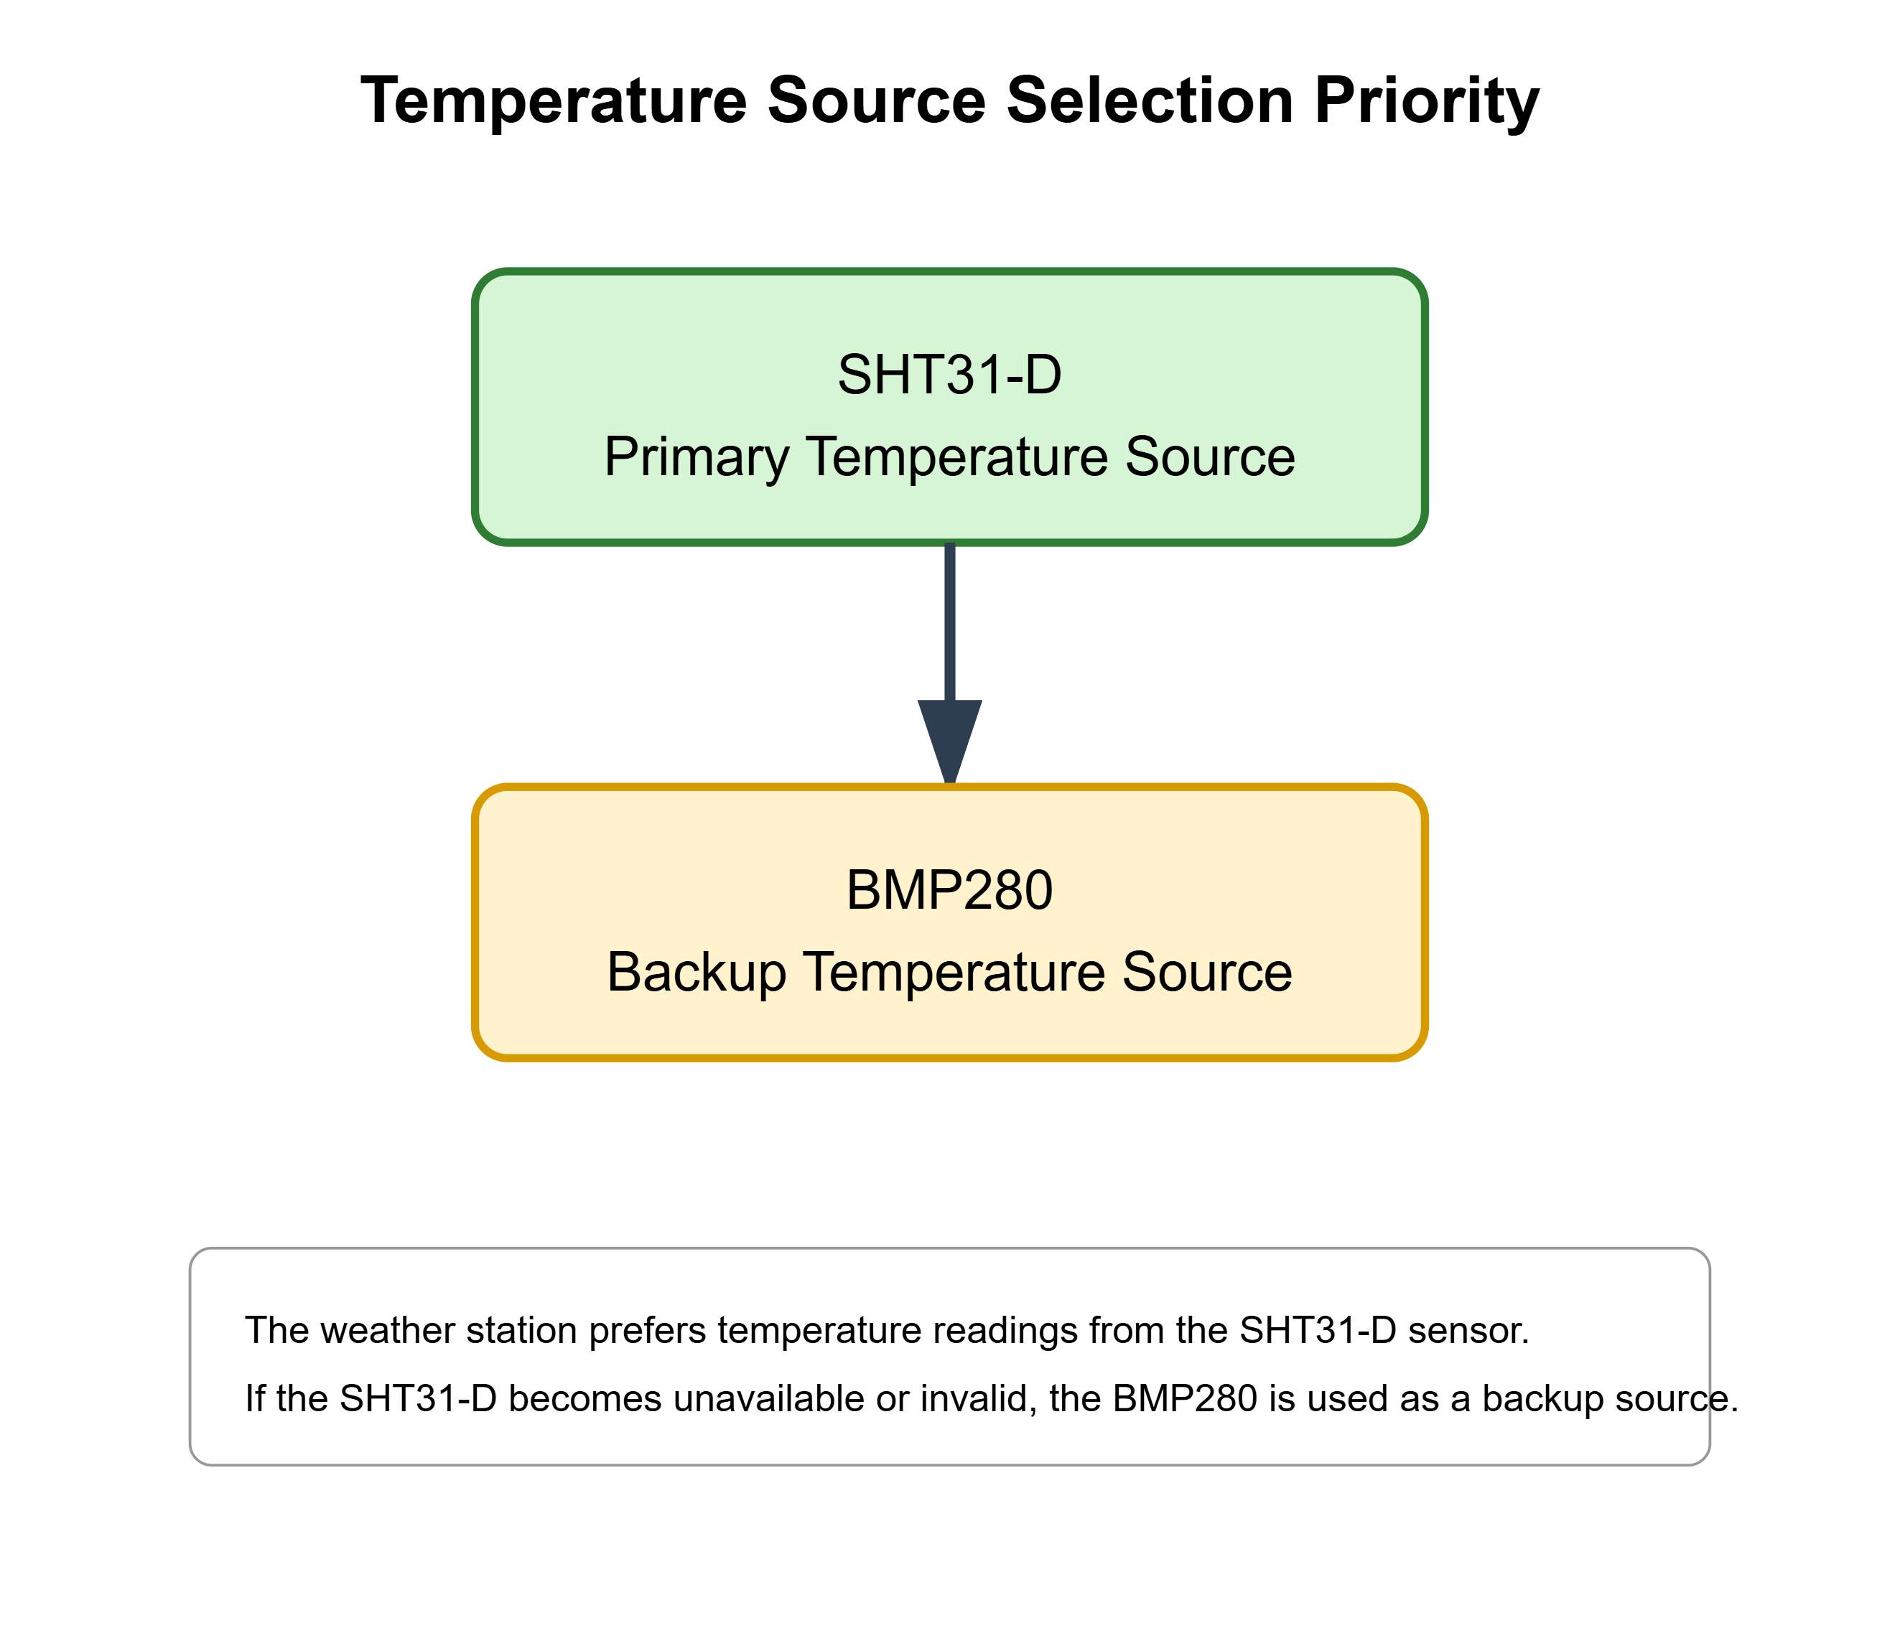If the primary source becomes invalid, the firmware automatically transitions to the backup source.
This improves system resilience and reduces data loss.

5.5 Min/Max Tracking Engine
The weather station continuously tracks environmental extremes.
Tracked values:

Minimum Temperature
Maximum Temperature
Minimum Humidity
Maximum Humidity
Minimum Pressure
Maximum Pressure
Associated timestamps are stored for every record.

Timestamp Components
Records contain:

Month
Day
Hour
Minute
allowing operators to determine when the extreme occurred.

5.6 Temperature Suppression System
Objective
The suppression system compensates for known afternoon temperature influences that can elevate readings beyond representative ambient conditions.

Operating Window
The correction operates during:

15:00 to 20:00

Correction Model
The adjustment follows a smooth sinusoidal curve.
Conceptually:
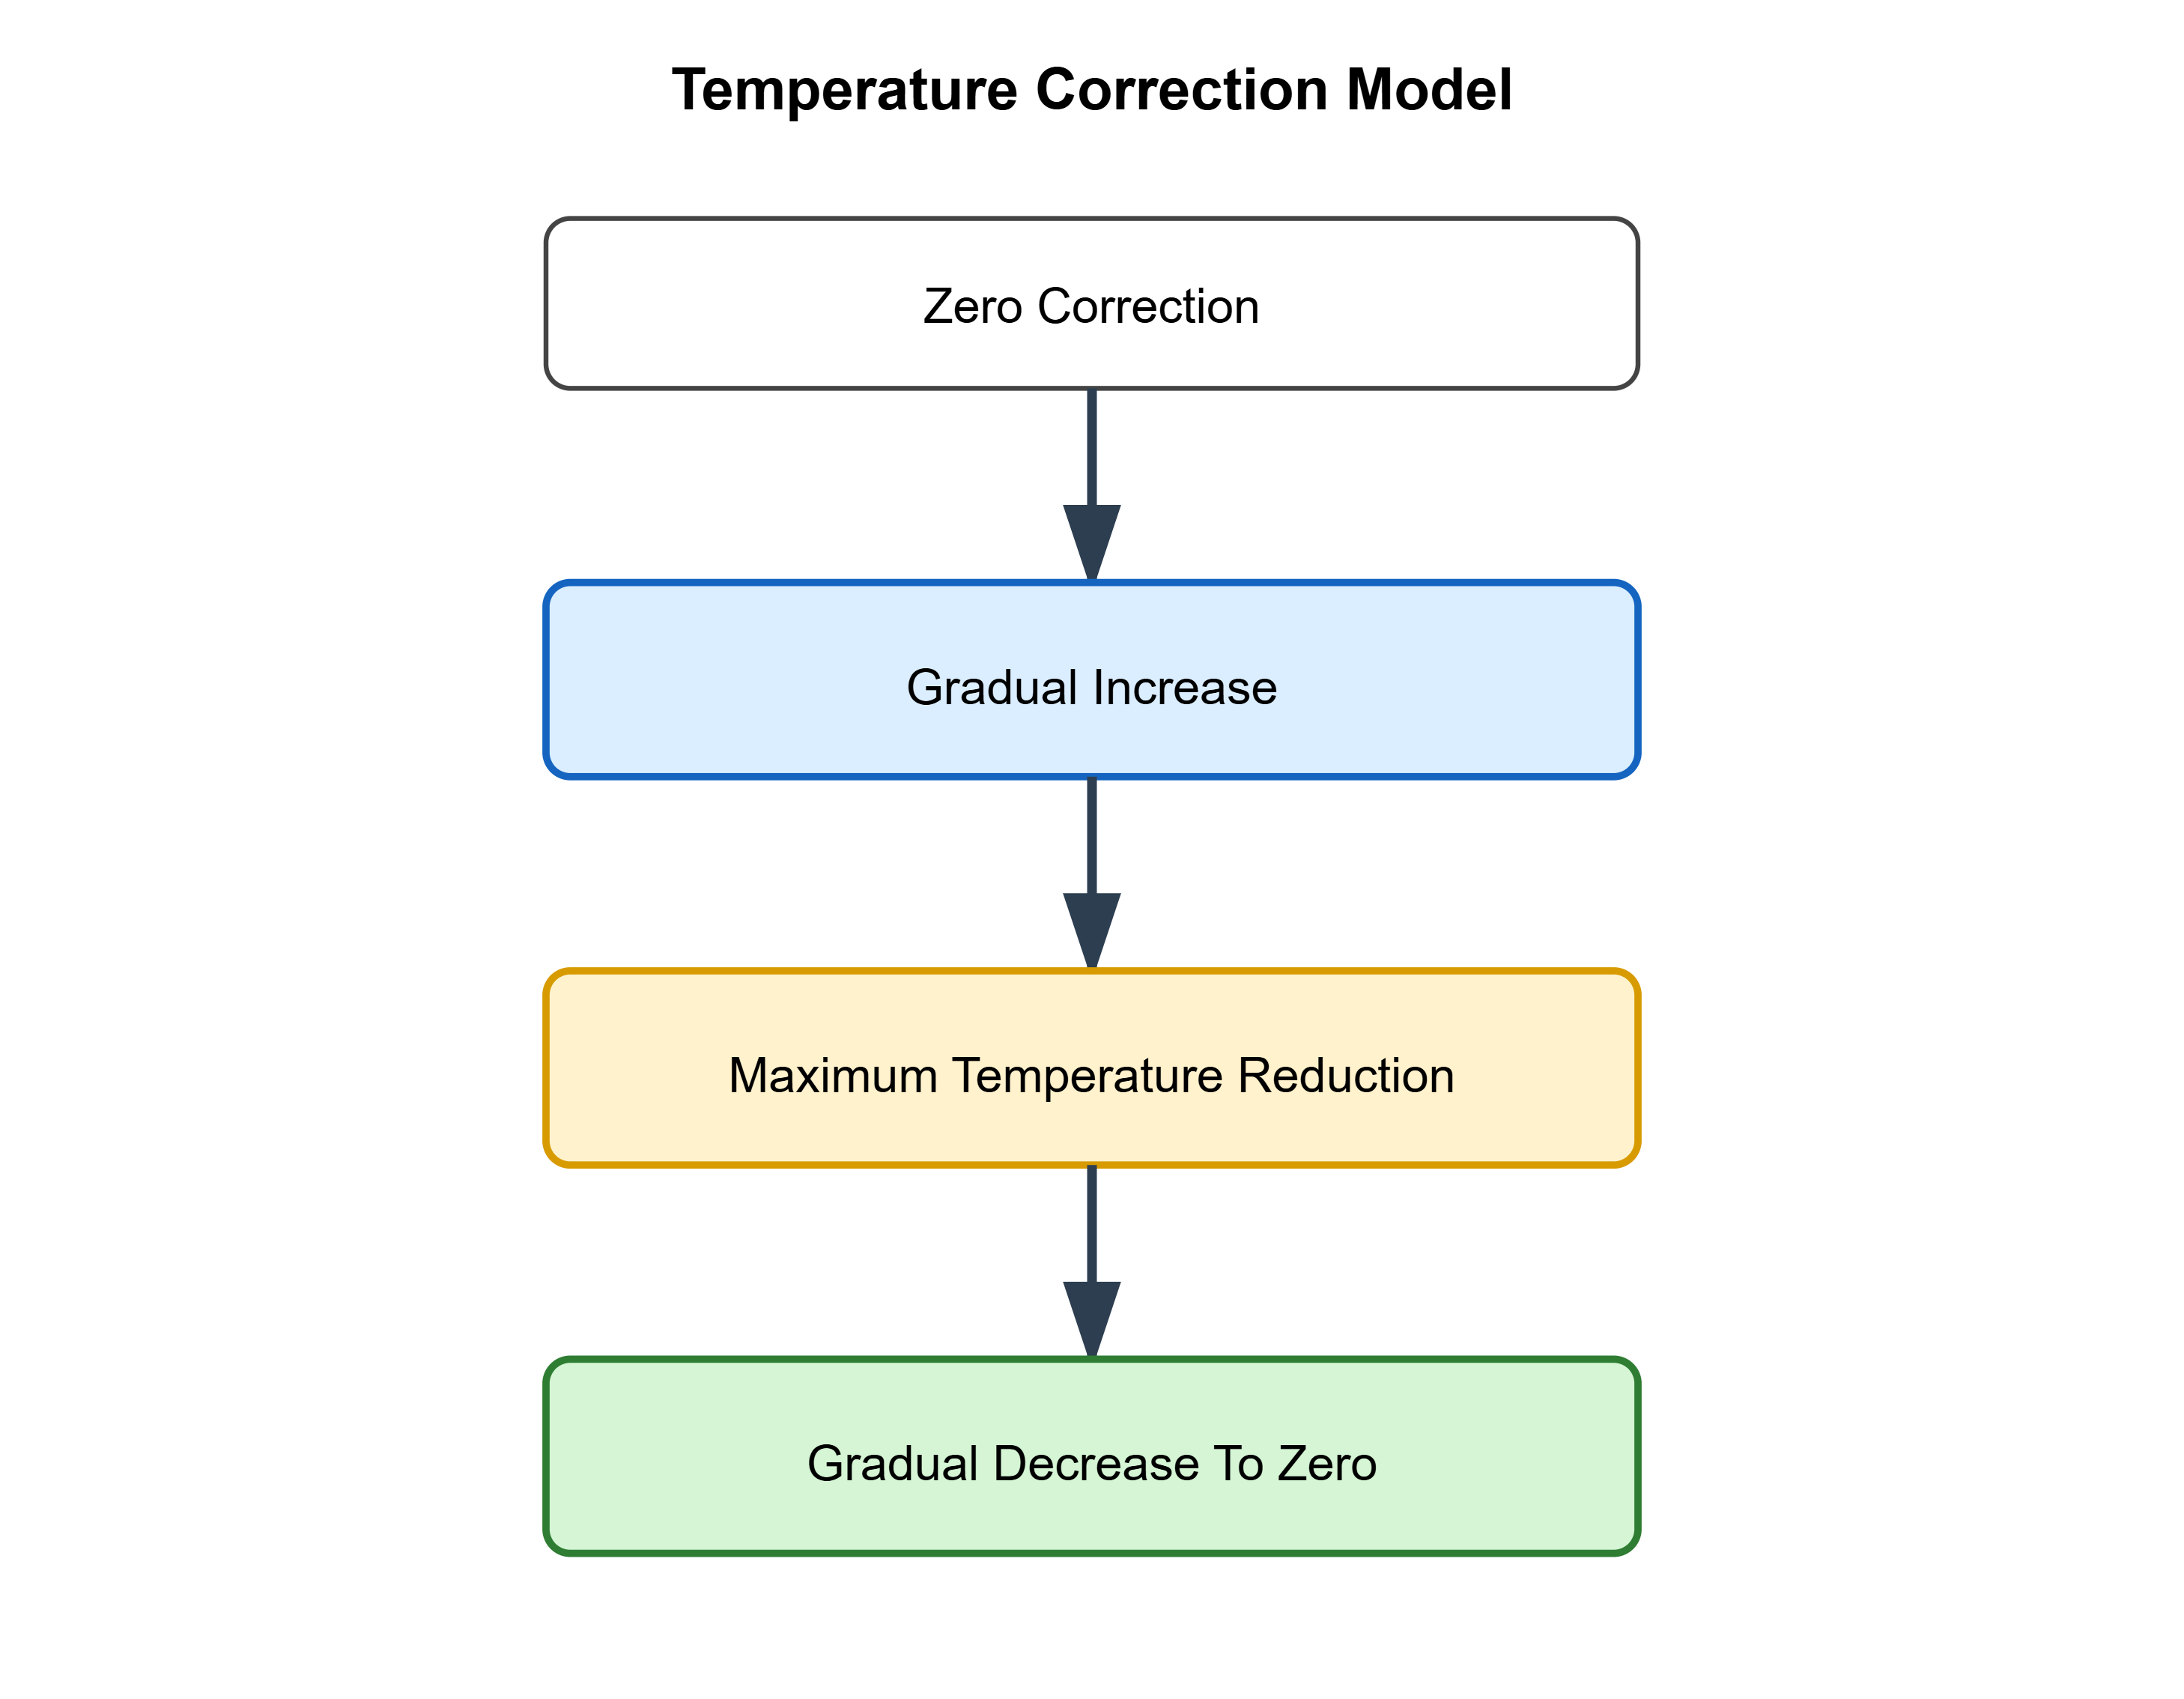This avoids abrupt transitions while maintaining consistent environmental reporting.

5.7 EEPROM Manager
The firmware stores persistent data in EEPROM.
Stored information includes:

Min Temperature
Max Temperature
Min Humidity
Max Humidity
Min Pressure
Max Pressure
Altitude
Reset Information
EEPROM preservation ensures critical information survives power interruptions.

5.8 RTC Management
The DS3231 RTC provides:
- Date
- Time
- Daily rollover detection
The RTC acts as the authoritative time source for:

Weather Records
Database Uploads
Min/Max Timestamps
Daily Resets

5.9 Daily Reset Processing
At day rollover:
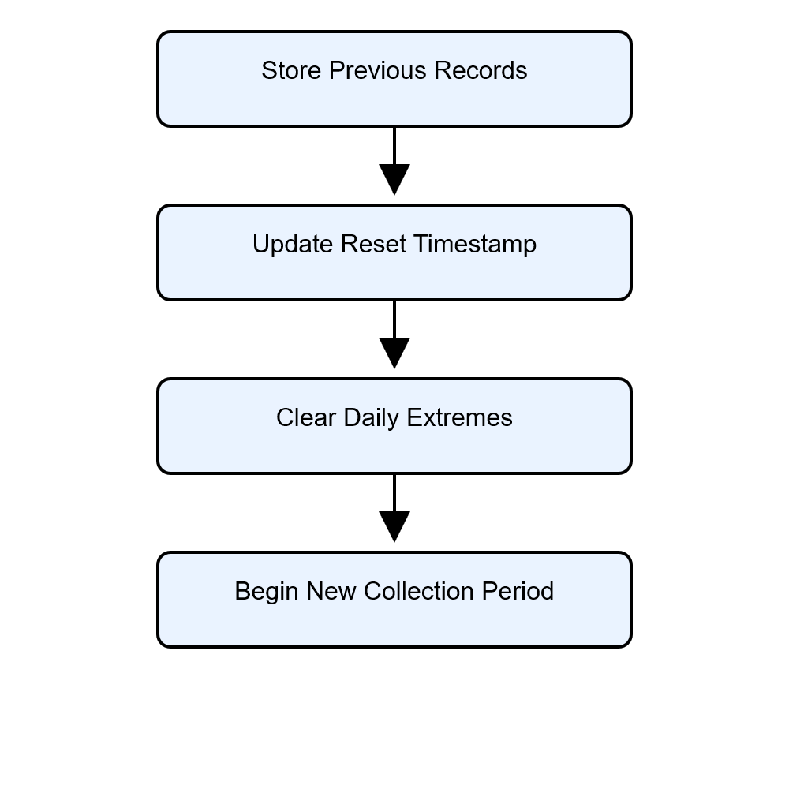
This process ensures clean separation between daily observation periods.

5.10 Outdoor Communications Supervision
The Mega continuously evaluates outdoor telemetry health.
Monitoring criteria include:

Packet Arrival
Packet Freshness
Outdoor Uptime
Recovery State

Warning Threshold

30 Seconds
without valid updates.
Recovery Threshold

60 Seconds
without valid updates.

5.11 Remote Reboot Manager
If communications are lost, the Mega can initiate recovery.
Process:
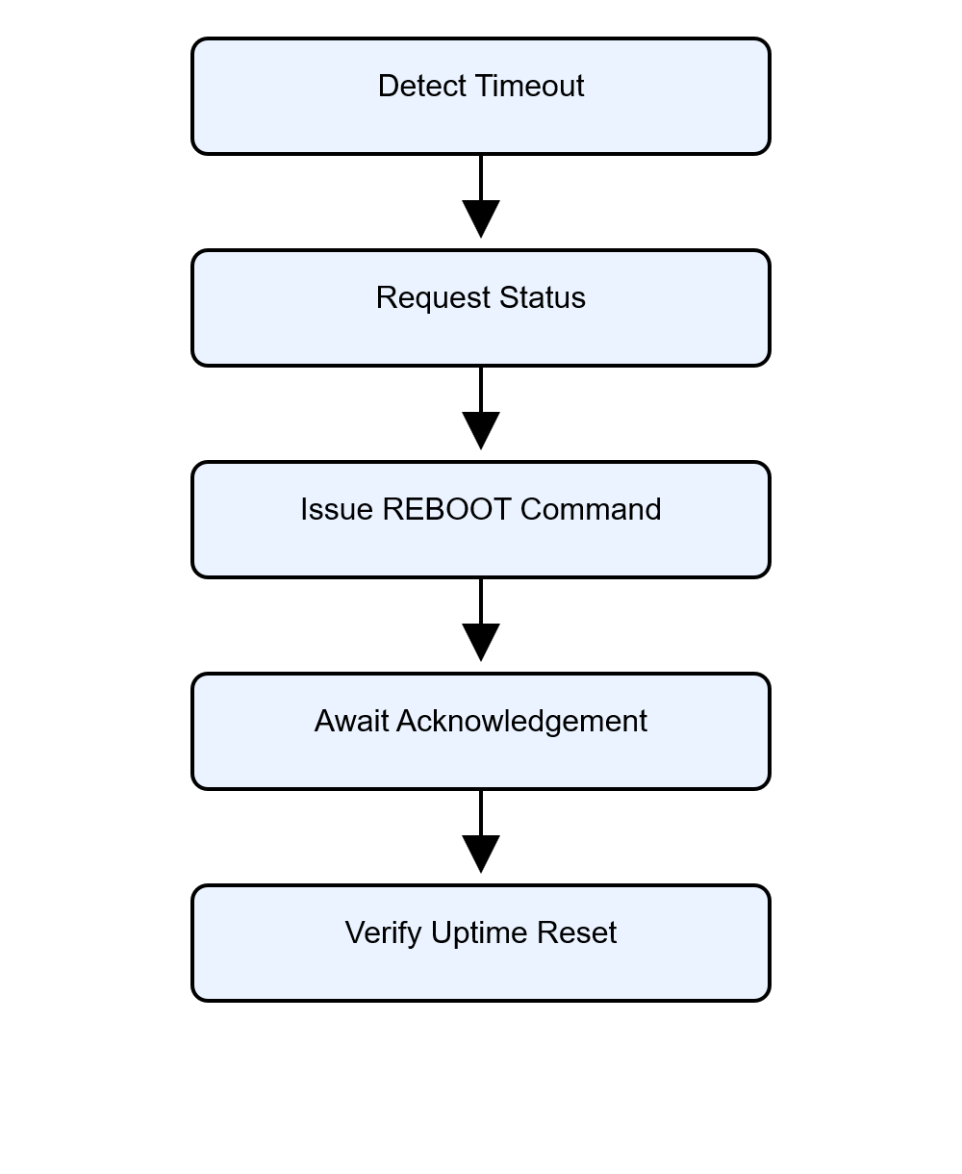
Maximum retries: 3

5.12 Weather Packet Generation
Once all measurements are consolidated, the Mega generates a weather-report packet for the ESP32-S3.
Typical contents include:

Temperature
Humidity
Dew Point
Pressure
Wind Speed
Wind Gust
Wind Direction
Rainfall
Rain Rate
Daily Rain
Outdoor Uptime
Date
Time

Transmission interval: Approximately 5 seconds

Section 6 – ESP32-S3 Gateway Firmware
6.1 Purpose
The ESP32-S3 acts as the Internet gateway and data-presentation platform.
Responsibilities include:
- Wi-Fi connectivity
- Dashboard generation
- Database uploads
- Weather Underground uploads
- Status monitoring
- Communications supervision

6.2 Gateway Data Flow
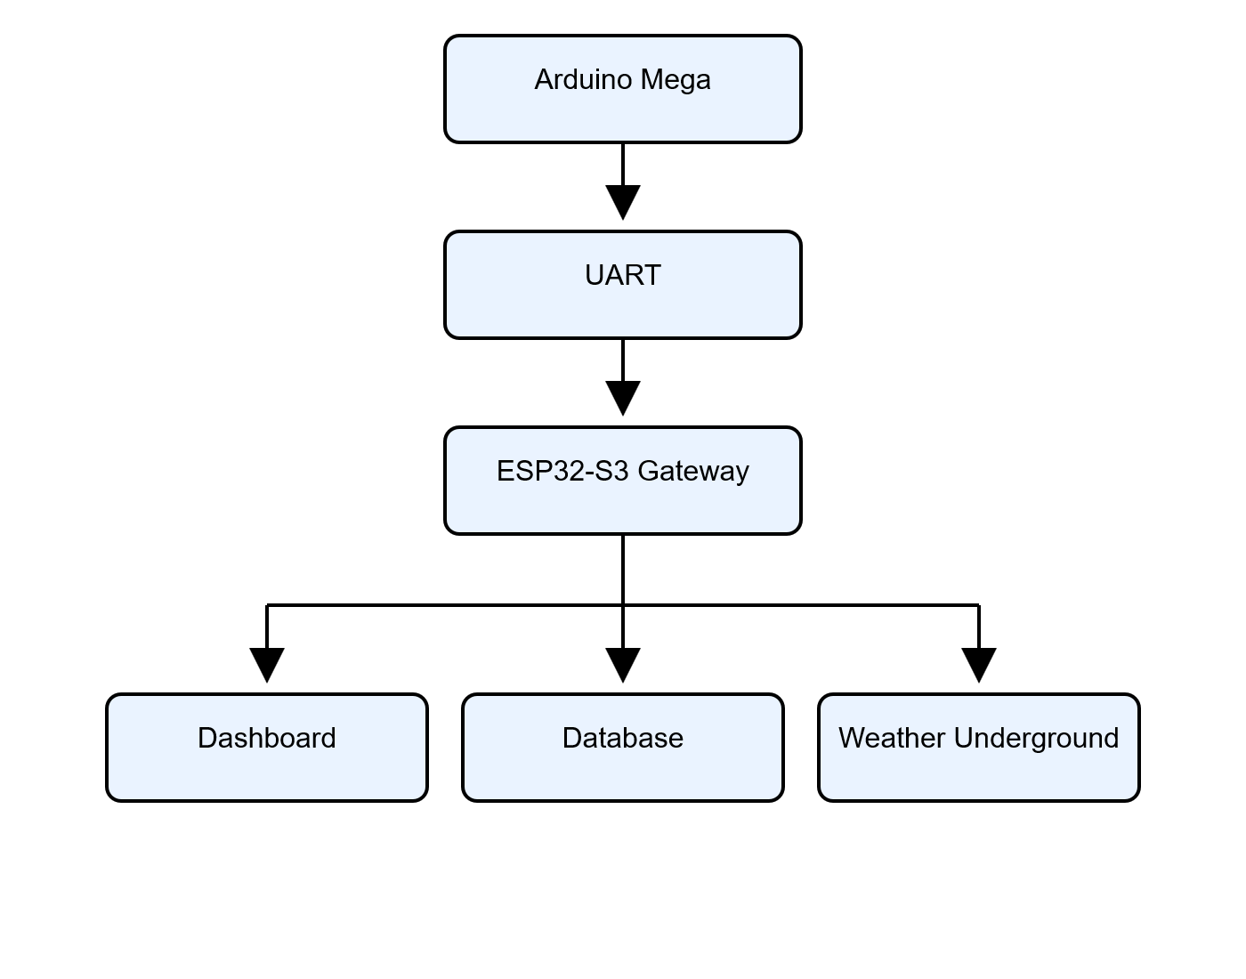The gateway does not generate weather data.
Instead, it receives processed information from the Mega.

6.3 UART Processing Engine
The ESP32-S3 continuously monitors UART traffic from the Mega.
The parser extracts:

Temperature
Humidity
Pressure
Wind Data
Rain Data
System Status
These values become dashboard variables.

6.4 Dashboard Engine
The gateway hosts a browser-accessible dashboard.
Displayed information includes:

Temperature
Humidity
Dew Point
Pressure
Wind
Rain
Outdoor Uptime
Weather Underground Status
The dashboard serves as the primary remote-monitoring interface.

Figure 6-1. Dashboard Data Flow
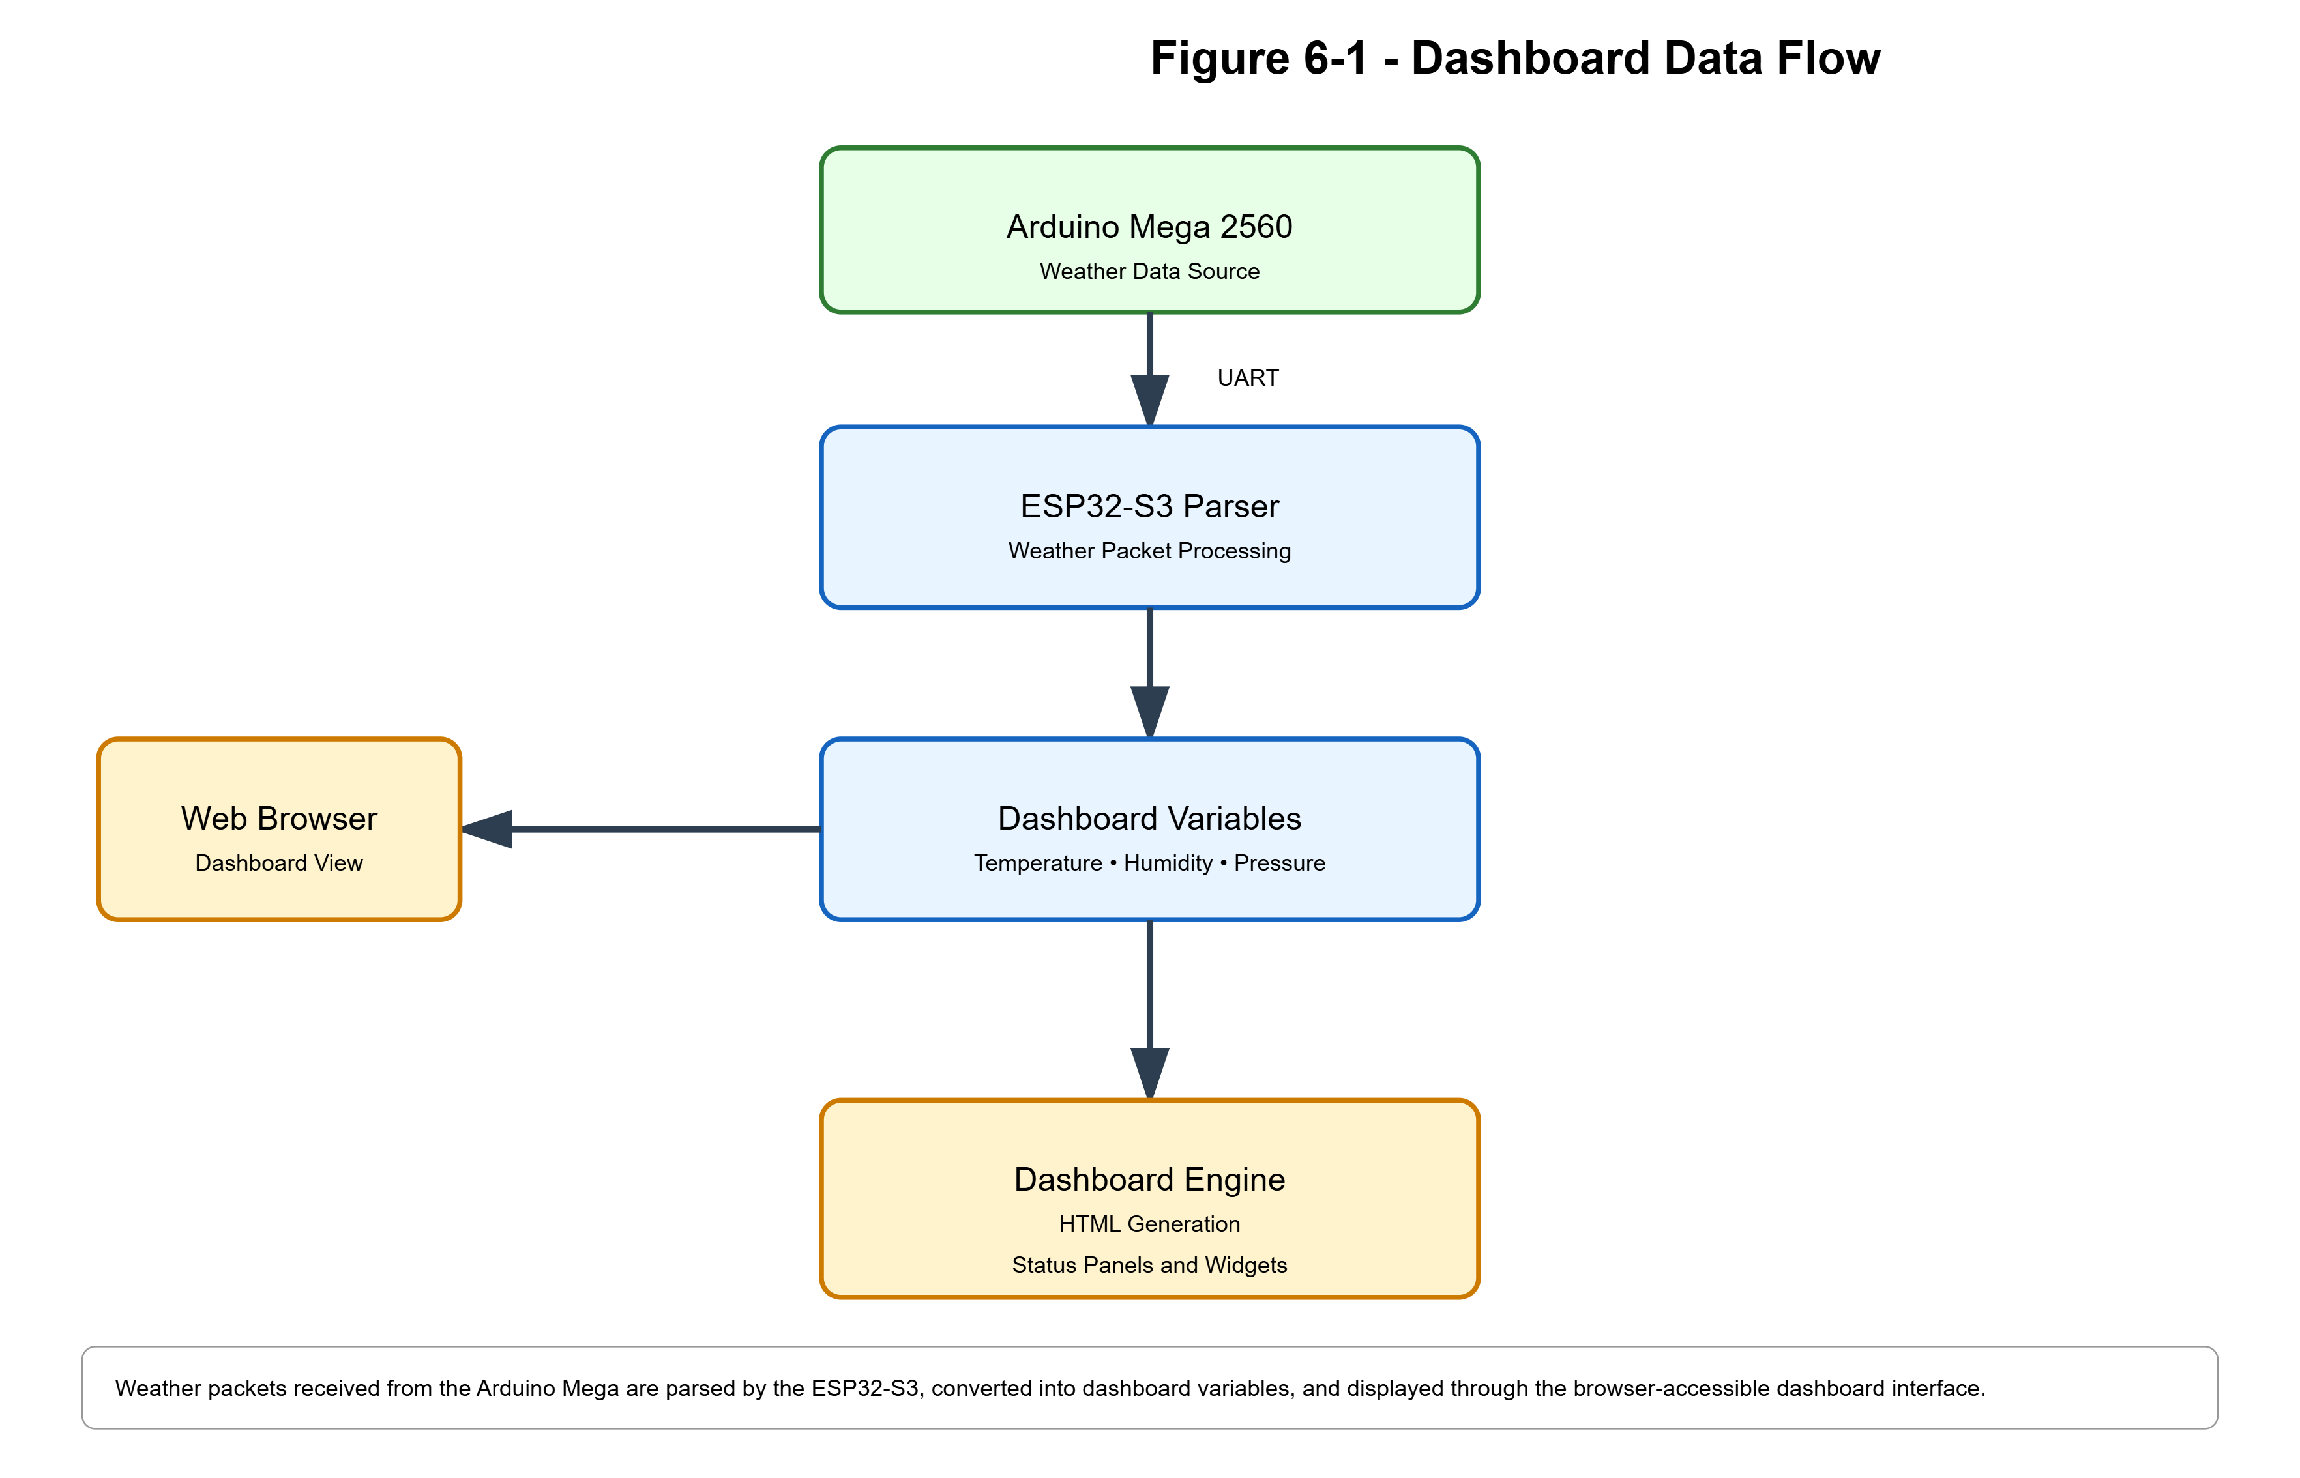
Processing path used by the ESP32-S3 gateway to transform weather packets into dashboard content.

6.5 Weather Underground Integration
The ESP32-S3 performs all Weather Underground communications.
Functions:

Generate Upload Request
Transmit Data
Evaluate Success
Update Status
Dashboard classifications:

ONLINE
DEGRADED
OFFLINE

6.6 Database Upload Engine
The gateway uploads weather information to:

weatherdb.php
Data categories include:
- Environmental values
- Health metrics
- Upload status
- Time information

6.7 Moisture Analysis
The gateway calculates:

Dew Potential
Moisture Classification
These calculated values simplify interpretation of humidity data.

6.8 Health Monitoring
The gateway tracks:

Wi-Fi Status
Database Status
Weather Underground Status
Upload Success
These values provide early warning of communications issues.

6.9 Recovery Logic
If communications failures exceed acceptable limits, the ESP32-S3 may initiate self-recovery procedures.
Goals:
- Restore uploads
- Restore dashboard operation
- Restore connectivity

Section 7 – ESP32-C3 Outdoor Node Firmware
7.1 Purpose
The outdoor ESP32-C3 functions as the environmental telemetry controller.
Responsibilities include:
- Wind-speed measurement
- Wind-direction processing
- Rainfall measurement
- LoRa communications
- Uptime reporting

7.2 Sensor Interfaces
Wind Vane

GPIO0
ADC-based sensing.

Anemometer

GPIO10
Interrupt-driven pulse counting.

Rain Gauge

GPIO3
Interrupt-driven pulse counting.

7.3 Wind Measurement System
The anemometer generates reed-switch transitions.
Process:

Pulse Detection
↓
Count Accumulation
↓
Wind-Speed Calculation

7.4 Gust Processing
The firmware continuously tracks peak instantaneous wind activity.
Result:

Maximum Gust
reported within outgoing telemetry packets.

7.5 Wind-Direction Processing
The wind vane produces a variable resistance network.
The firmware converts:

ADC Reading
into
Compass Direction
in
Degrees

before transmission.

7.6 Rainfall Processing
The tipping-bucket rain gauge generates pulse events.
Measurements include:

Rain Tips
Rain Rate
Daily Rainfall

7.7 LoRa Packet Construction
The outdoor node builds telemetry packets approximately every five seconds.
Packet contents:

Wind Speed
Wind Gust
Wind Direction
Rain Rate
Daily Rain
Rain Tips
Uptime

7.8 Uptime Monitoring
The ESP32-C3 continuously reports uptime.
Benefits:
- Health monitoring
- Recovery verification
- Communications diagnostics

7.9 Remote Command Processing
Supported commands:

STATUS
REBOOT
These commands allow remote supervision by the Arduino Mega.

Section 8 – Communications Protocols
8.1 Purpose
The communications subsystem links all weather-station components into a unified architecture.

Figure 8-1. Communications and Data Acquisition Architecture
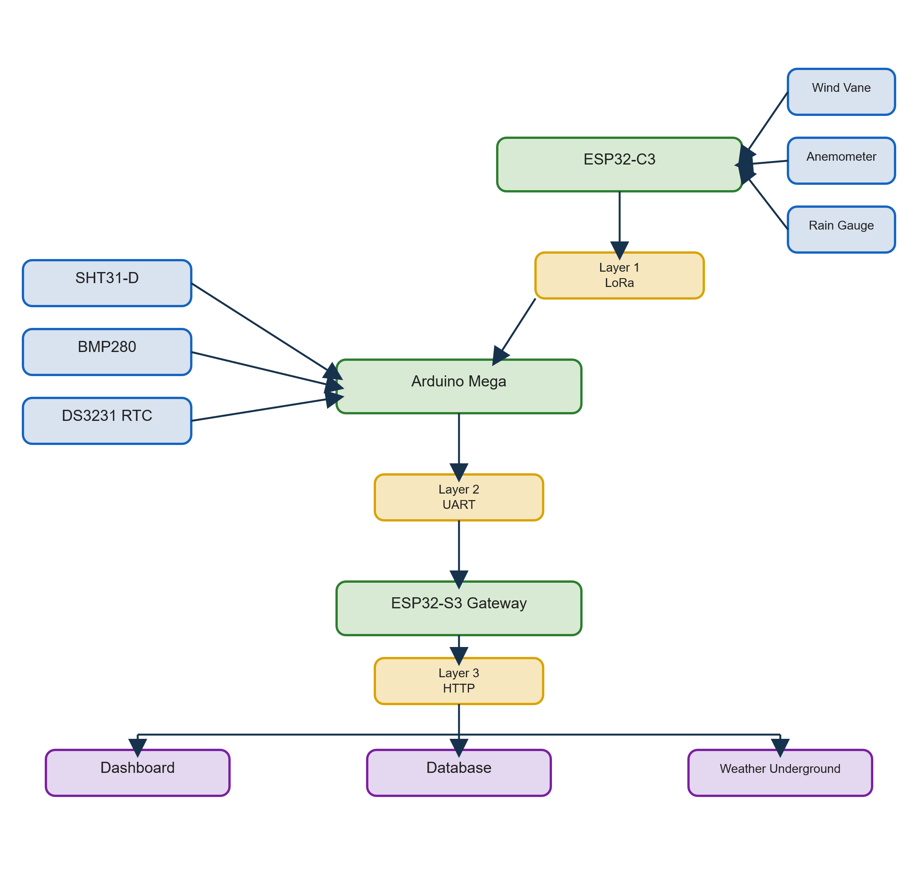
End-to-end weather-data flow from outdoor sensors through the control system and into dashboard and cloud services.

8.2 Communications Layers
Layer 1

LoRa
Outdoor telemetry.

Layer 2

UART
Mega-to-gateway communications.

Layer 3

HTTP
Internet communications.

8.3 LoRa Weather Packet
Packet identifier:
<OUT>
Structure:

WindSpeed,
WindGust,
Direction,
RainRate,
DailyRain,
RainTips,
Uptime

Update interval: ~5 Seconds

8.4 Status Protocol
Query:

<STATUS?>
Response:

<STATUS>
Purpose:
Verify node health when telemetry becomes stale.

8.5 Remote Reboot Protocol
Command:

<REBOOT>
Acknowledgement:

<REBOOTING>
Verification:

Uptime Reset

8.6 UART Weather Packet
The Mega forwards consolidated weather information to the ESP32-S3.
Fields include:

Temperature
Humidity
Pressure
Wind
Rain
Uptime
Date
Time

8.7 HTTP Uploads
Destination services:

Database
Weather Underground
The ESP32-S3 performs all upload operations.

8.8 Communications Timing
Activity | Interval
LoRa Telemetry | ~5 sec
UART Update | ~5 sec
Status Check | ~30 sec
Reboot Trigger | ~60 sec
Retry Count | 3

8.9 Communications Health Monitoring
The architecture continuously monitors:

LoRa Health
Gateway Status
Upload Status
Database Connectivity
Weather Underground Connectivity
This layered monitoring structure provides robust fault detection and recovery.

Sections 9–14
Database, Dashboard, Algorithms, Installation, Troubleshooting, and Maintenance

Section 9 – Database Design
9.1 Purpose
The database subsystem provides long-term storage of weather and operational data generated by the weather station. While the Arduino Mega and ESP32-S3 maintain current operating values, the database preserves historical observations for reporting, troubleshooting, trend analysis, and future dashboard enhancements.
The database serves as the permanent historical record of station operation.

9.2 Database Architecture
The database resides downstream of the weather-acquisition chain.
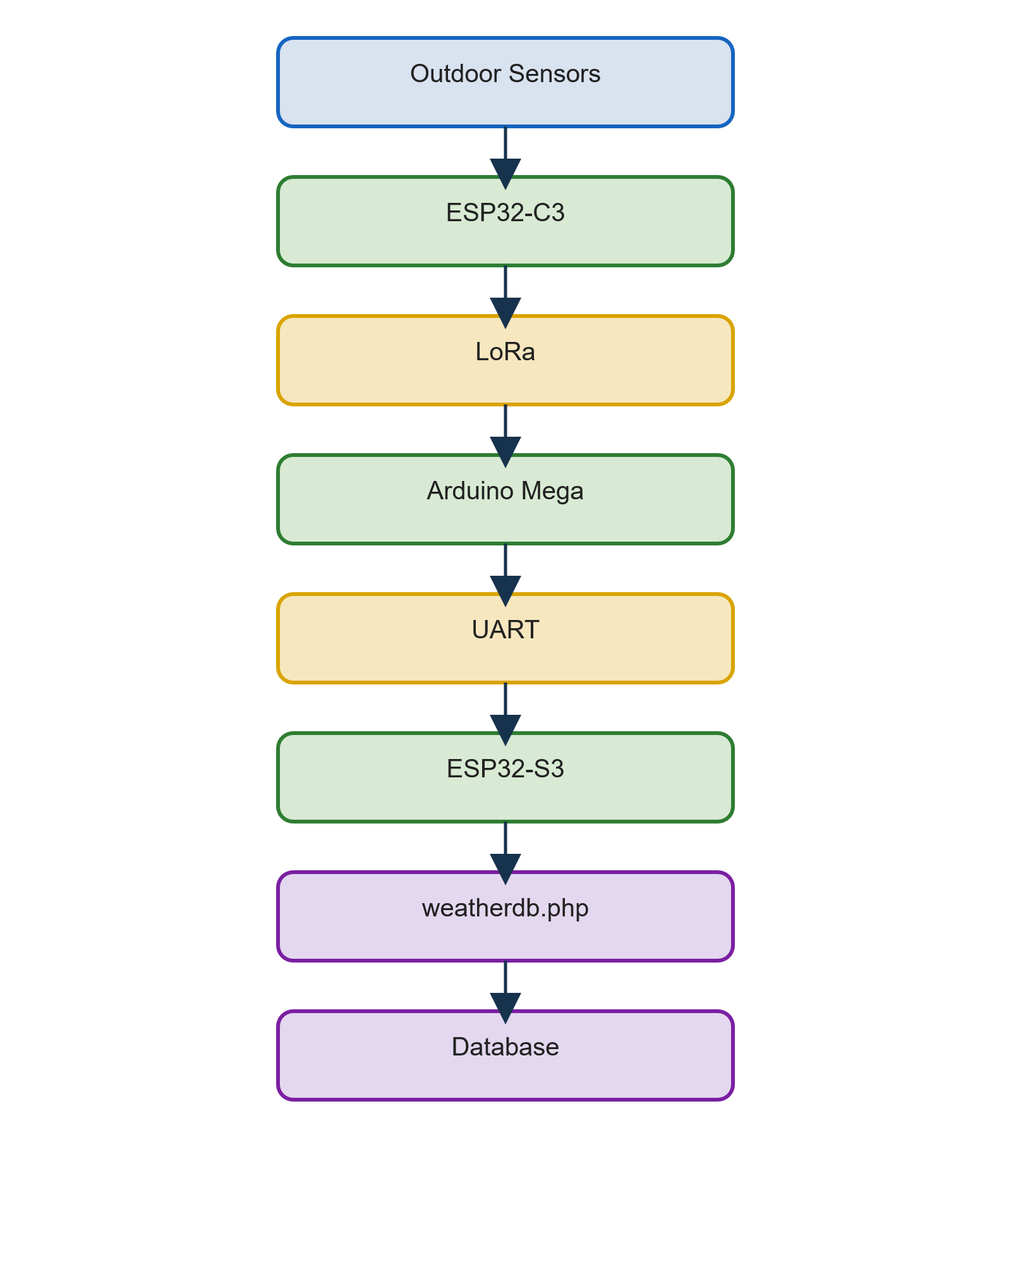
This separation allows weather acquisition to continue even when database services are unavailable.

9.3 Design Objectives
The database design was developed to meet several goals:
- Provide historical weather storage
- Preserve raw and corrected values
- Support future reporting tools
- Support dashboard displays
- Simplify troubleshooting
- Record system-health information

9.4 Observation Records
Each database record represents a single observation event.
Typical categories include:

Environmental Conditions
System Health
Upload Status
Timestamp Information
Each observation is timestamped and archived for later retrieval.

9.5 Environmental Data
Stored environmental information includes:
Temperature

temp
rawtemp
adjfactor

Humidity

humidity
dewpt
moist
dewpot

Pressure

presshpa
pressinhg

Wind

winddir
windspd
windgust
windlast

Rain

rainrate
rainday
raintips

9.6 System-Health Data
The database stores operational status information.
Examples:

Outdoor Uptime
Weather Underground Status
Last Connection
Next Upload Information
These values greatly simplify fault diagnosis.

9.7 Observation Lifecycle
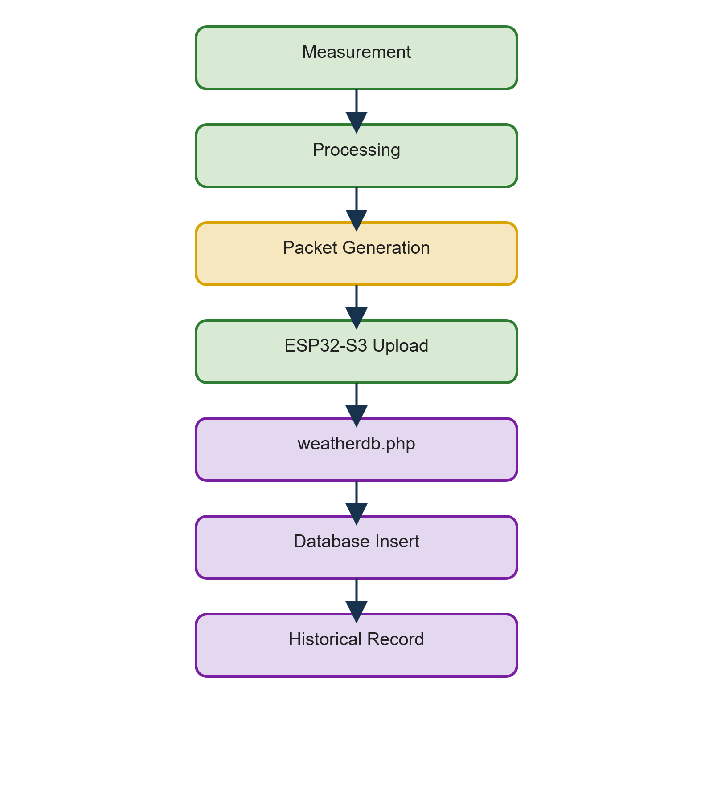

9.8 Database Failure Tolerance
One design objective was fault isolation.
If database services fail:

Weather Collection Continues
LCD Continues
LoRa Continues
Dashboard Continues
Only historical record insertion is affected.

9.9 Future Database Applications
The current schema supports:
- Historical weather charts
- Rainfall reports
- Uptime analytics
- Reliability analysis
- Trend forecasting
without requiring major structural changes.

Section 10 – Dashboard Design
10.1 Purpose
The dashboard provides remote visibility into weather conditions and station health.
Unlike the LCD display, which is intended for local operation, the dashboard is accessible through a standard web browser and provides a complete system overview.

10.2 Dashboard Architecture
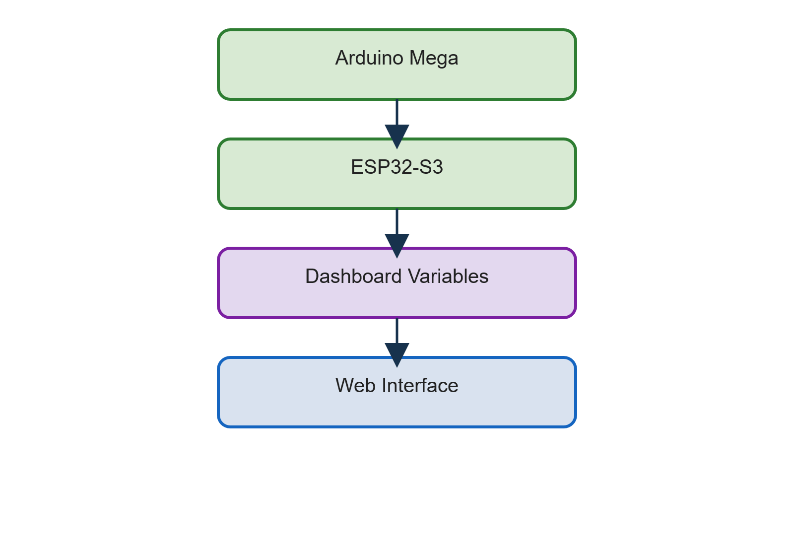
The dashboard reflects the most recent weather information received by the gateway.

10.3 Design Goals
The dashboard was designed to provide:
- Rapid readability
- Mobile compatibility
- System-health visibility
- Weather Underground visibility
- Near real-time updates

10.4 Main Dashboard Components
The dashboard displays:

Temperature
Humidity
Dew Point
Pressure
Wind
Rainfall
Outdoor Uptime
Weather Underground Status
Date/Time

Figure 10-1. Dashboard Screenshot
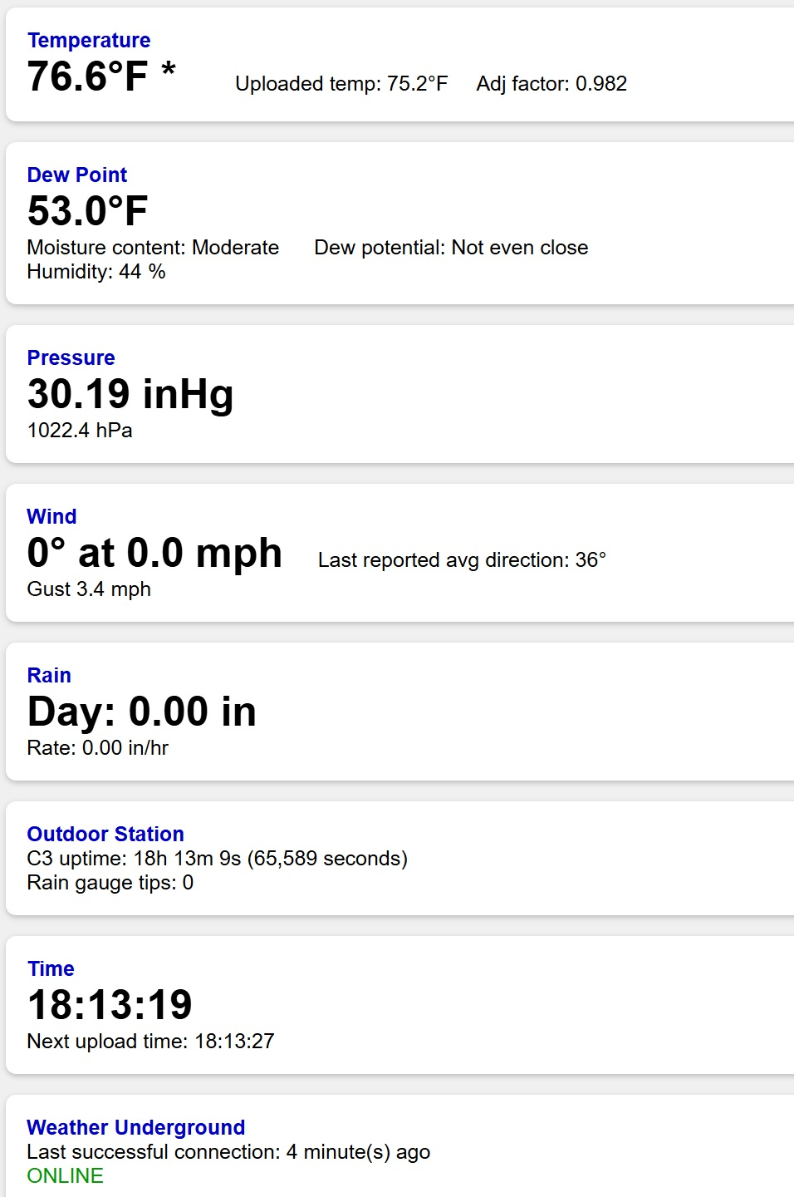
Primary dashboard interface showing current weather and system status.

10.5 Temperature Display
The temperature section shows:
- Corrected temperature
- Sensor-derived values
- Suppression-adjusted values
The displayed value represents the station's preferred weather temperature.

10.6 Humidity and Dew Point
The humidity section displays:

Relative Humidity
Dew Point
Moisture Classification
providing a quick understanding of atmospheric conditions.

10.7 Pressure Display
Pressure information is displayed using corrected sea-level pressure.
Available units include:

hPa
inHg

10.8 Wind Display
Wind information includes:

Current Speed
Wind Gust
Direction
These values originate from the outdoor node.

10.9 Rainfall Display
The rainfall section provides:

Rain Rate
Daily Rainfall
Rain-Gauge Status
This allows rapid assessment of precipitation conditions.

10.10 Outdoor Node Status
The dashboard displays:

Outdoor Uptime
Communication Health
A rapidly growing uptime indicates healthy operation.

10.11 Weather Underground Status
Status indicators:

ONLINE
DEGRADED
OFFLINE
provide visibility into cloud-upload performance.

10.12 Future Dashboard Enhancements
Potential upgrades include:
- Historical charts
- Rainfall graphs
- Pressure trends
- Wind roses
- Battery telemetry

Section 11 – Environmental Algorithms
11.1 Purpose
Environmental algorithms convert raw sensor measurements into useful meteorological information.
These algorithms improve usability while preserving scientific value.

11.2 Processing Pipeline
Figure 11-1. Environmental Processing Pipeline
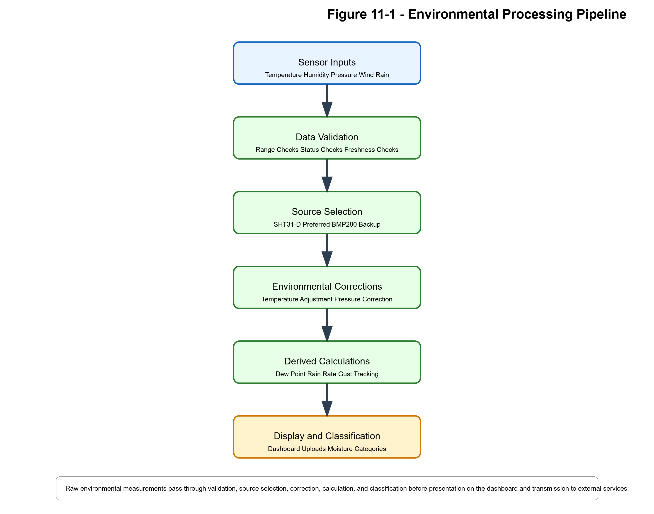
Environmental-data processing sequence from raw sensor measurements through correction, calculation, classification, display, and upload.

11.3 Temperature Source Selection
Temperature may originate from:

SHT31-D
BMP280
The system automatically selects the preferred valid source.

11.4 Temperature Suppression Algorithm
The firmware contains a time-based correction system intended to minimize elevated readings during a known afternoon interval.
Operating Window

15:00 – 20:00
Characteristics
- Smooth transition
- Gradual increase
- Gradual decrease
- No abrupt step changes

Figure 11-2. Temperature Suppression Curve
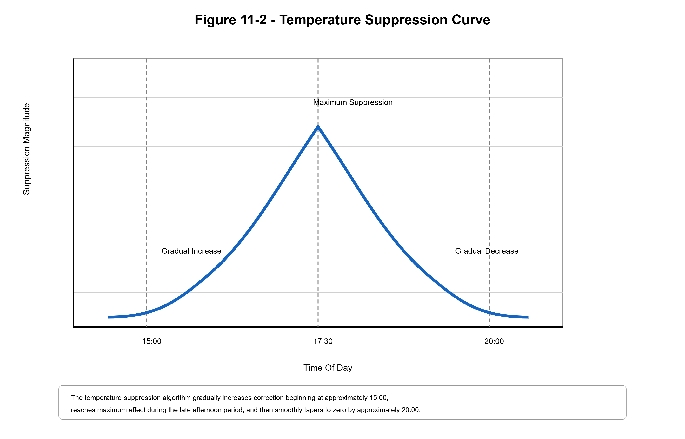
Representative temperature-adjustment profile used to compensate for afternoon heating effects while avoiding abrupt transitions.

11.5 Dew-Point Calculation
Dew point is calculated using temperature and humidity.
General process:

Temperature
+
Humidity
↓
Magnus Equation
↓
Dew Point

Figure 11-3. Dew Point Calculation Flow
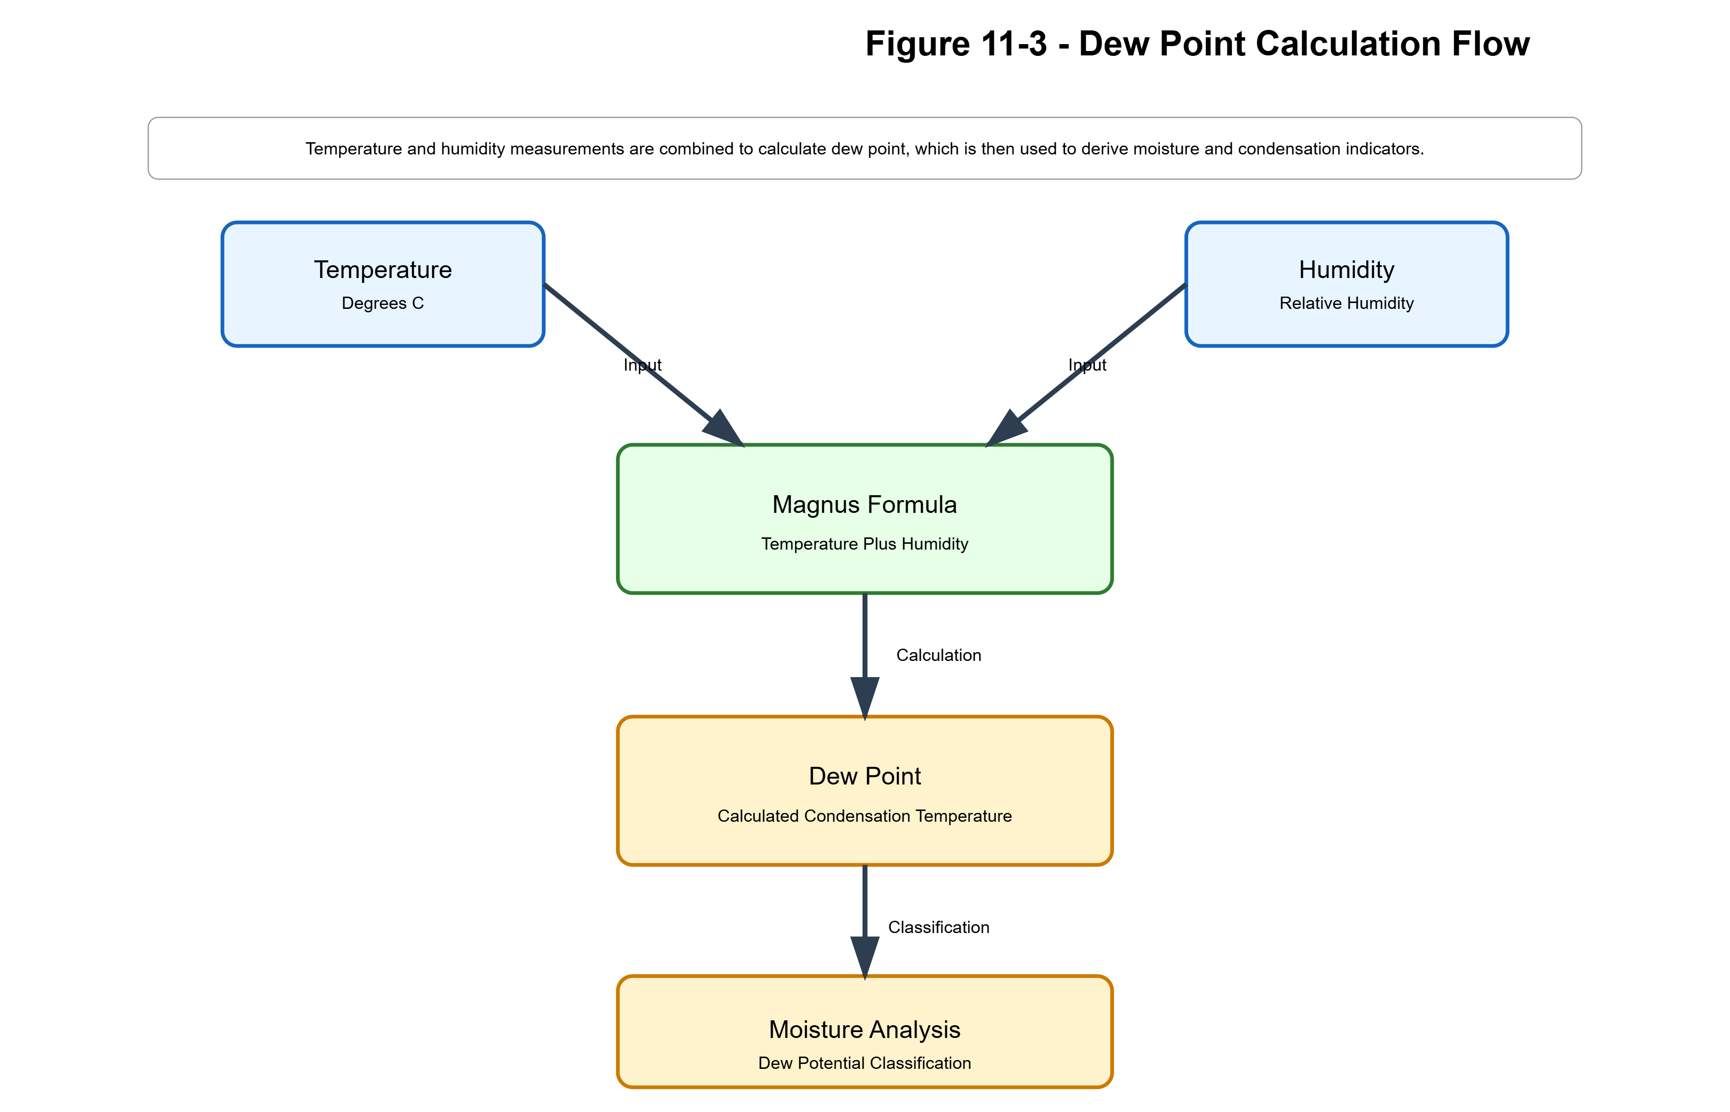
Dew-point generation process utilizing temperature and humidity measurements.

11.6 Pressure Correction
Pressure readings are corrected using station altitude.
Inputs:

Observed Pressure
Altitude
Output:

Sea-Level Pressure
This produces weather values comparable to nearby reporting stations.

11.7 Wind Processing
The outdoor node performs:

Pulse Counting
Wind-Speed Calculation
Gust Tracking
Direction Processing
before transmission.

11.8 Rainfall Processing
Rainfall calculations are derived from tipping-bucket events.
Generated values:

Rain Tips
Rain Rate
Daily Rainfall

11.9 Moisture Classification
The system generates human-readable environmental classifications from weather conditions.
Examples may include:

Dry
Comfortable
Humid
Very Humid

Section 12 – Installation and Physical Deployment
12.1 Purpose
This section describes physical deployment of the complete weather station.
The installation process includes:
- Mechanical mounting
- Electronics installation
- Power-system installation
- Communications verification

12.2 Physical Assemblies
The station consists of:

Outdoor Sensor Mast
Outdoor Electronics Enclosure
Solar Power System
Indoor Controller

12.3 Site Selection
Ideal installation locations provide:
- Good wind exposure
- Open rainfall collection
- Reliable LoRa communications
- Sufficient solar exposure

Figure 12-1. Outdoor Sensor Mast
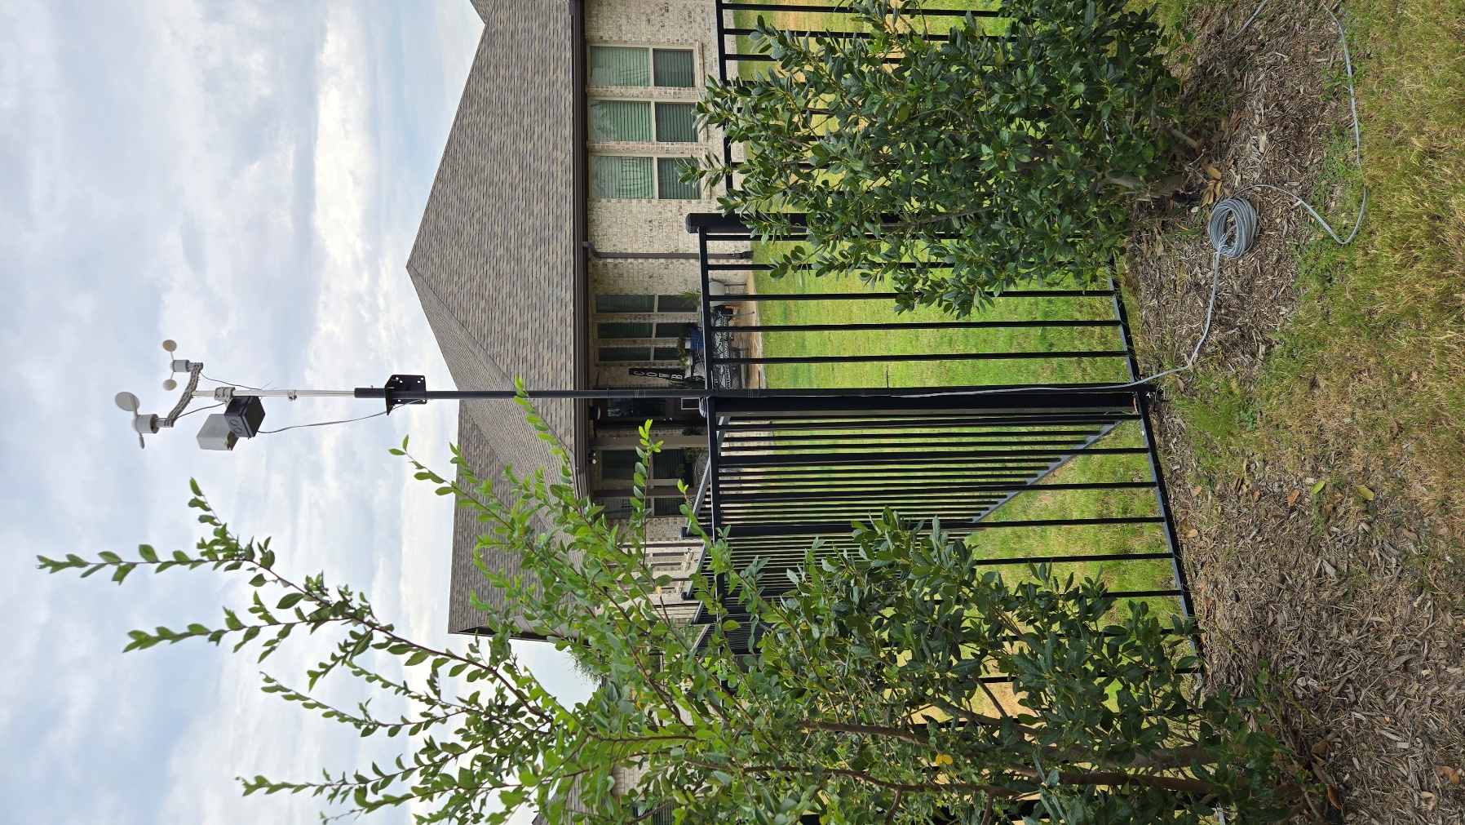
12.4 Wind Sensor Placement
Wind sensors should:
- Avoid obstructions
- Remain well above nearby structures
- Maintain unobstructed airflow

12.5 Rain Gauge Placement
The rain gauge should:
- Remain level
- Avoid roof runoff
- Avoid splash contamination
- Remain free of overhead obstructions

12.6 Radiation Shield Installation
The shield should:
- Remain ventilated
- Remain clean
- Avoid direct solar loading

Figure 12-2. Radiation Shield
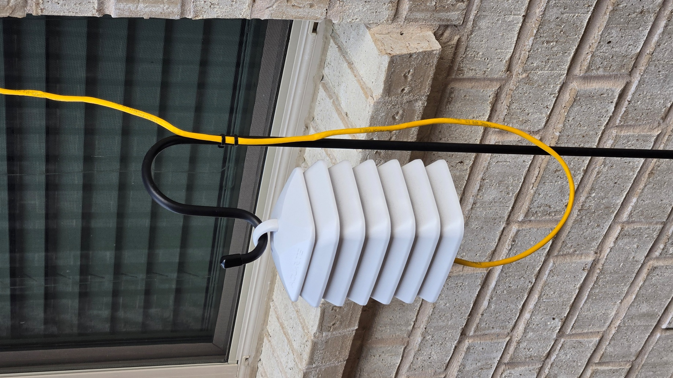
12.7 Solar Power Installation
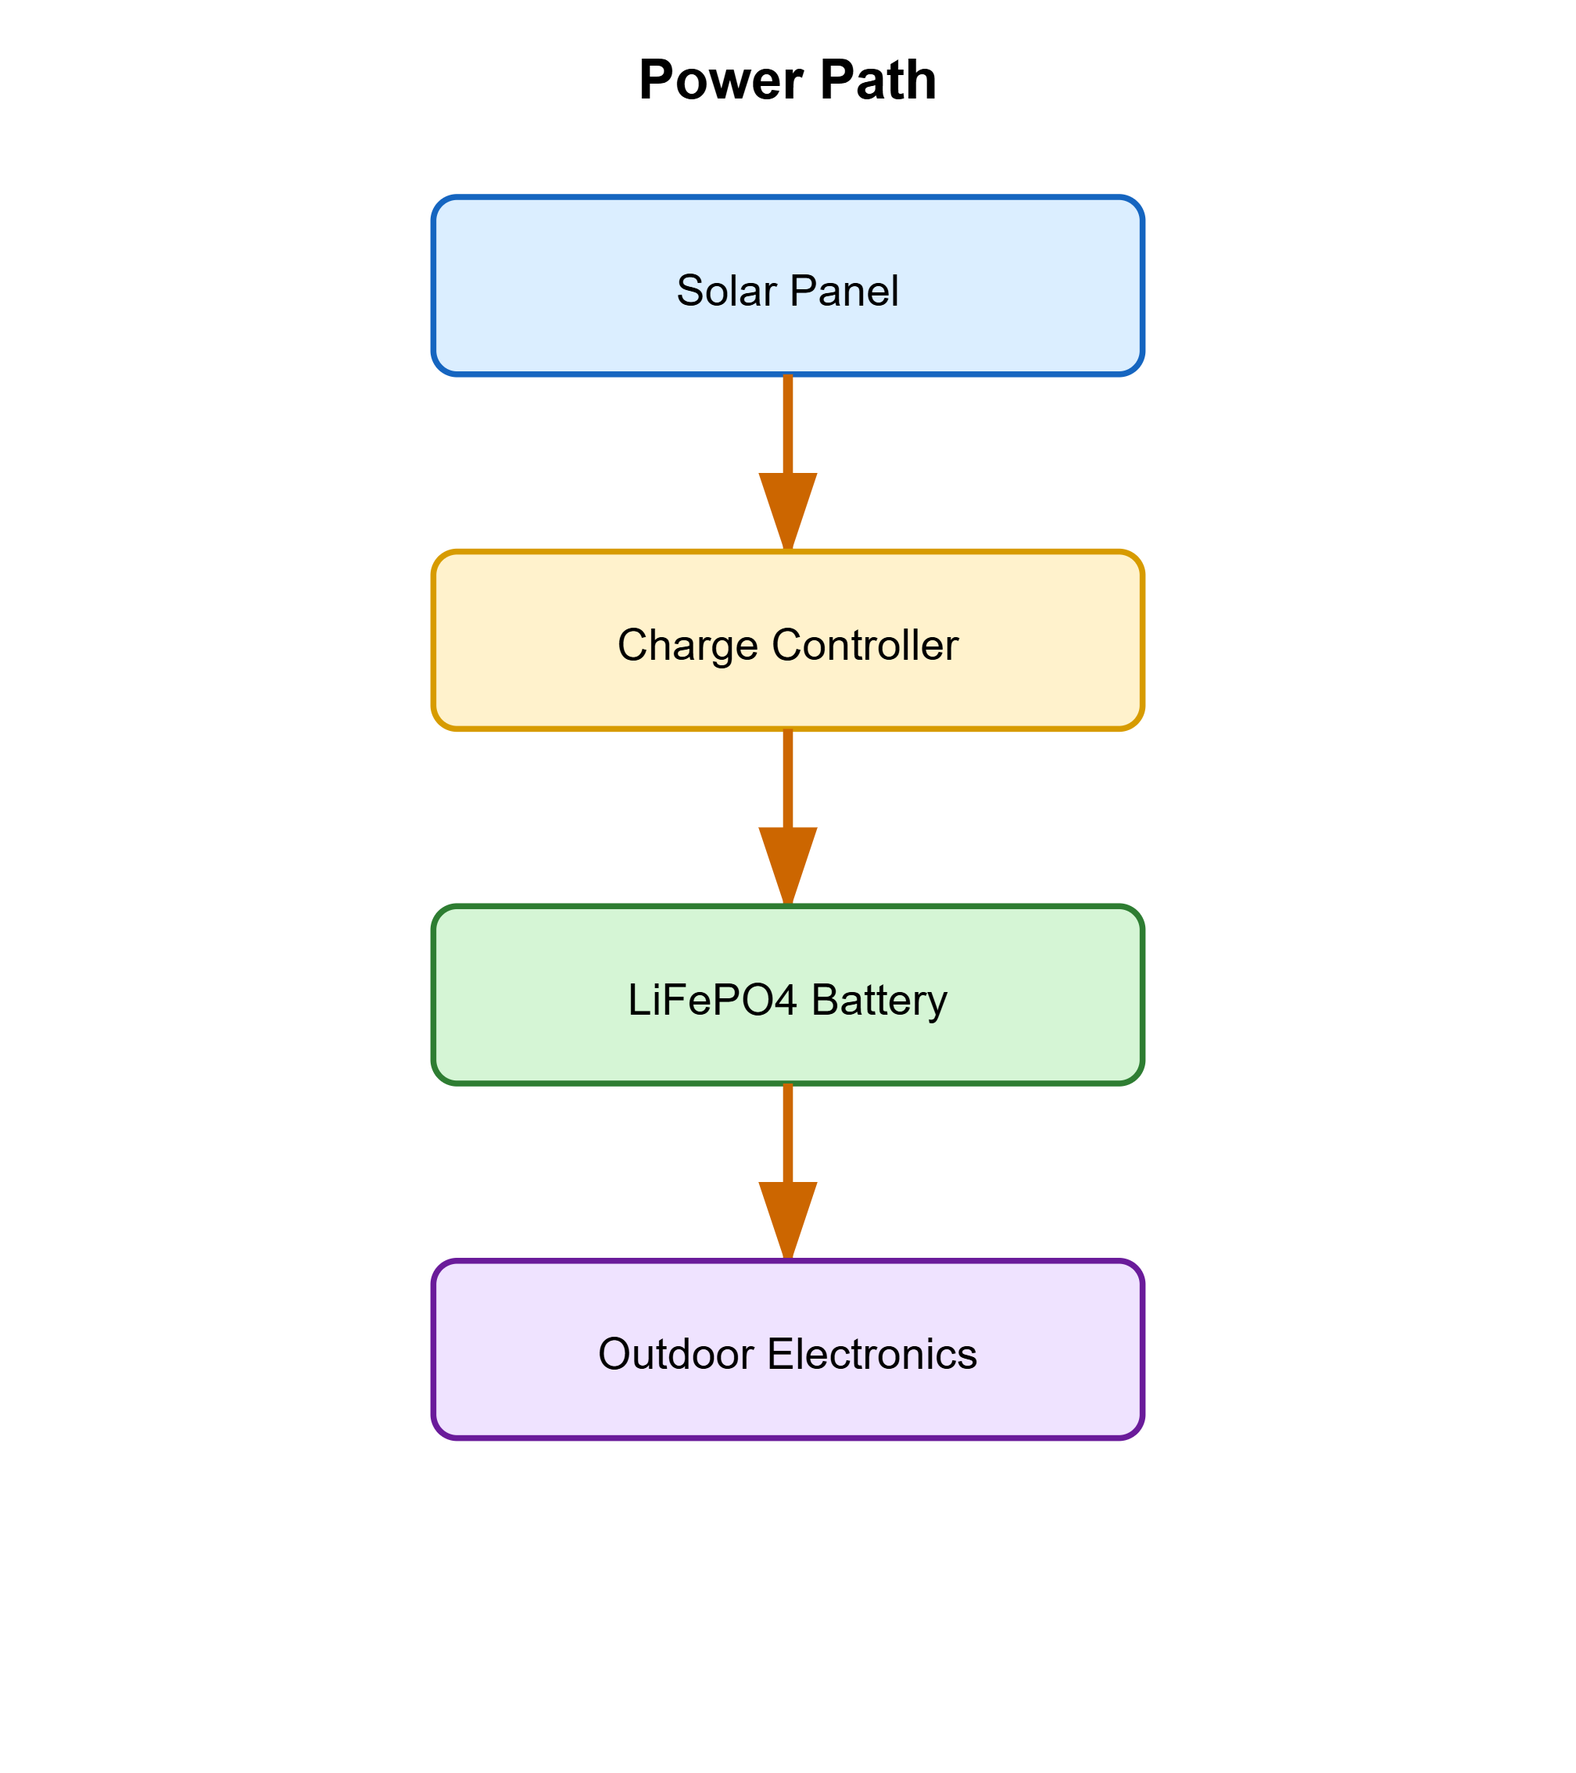
12.8 Indoor Controller Installation
The indoor station should be installed:
- Indoors
- Within LoRa range
- Near power
- Accessible for maintenance

12.9 Commissioning Tests
Verify:

LoRa Communication
Dashboard Operation
Database Uploads
Weather Underground Uploads
Sensor Function
RTC Accuracy
before placing the station into service.

Section 13 – Troubleshooting and Diagnostics
13.1 Purpose
The troubleshooting process is designed to rapidly isolate system failures.
The architecture intentionally exposes diagnostic information through:
- LCD displays
- Dashboard indicators
- Uptime reporting
- Communications status

13.2 Troubleshooting Sequence
Recommended sequence: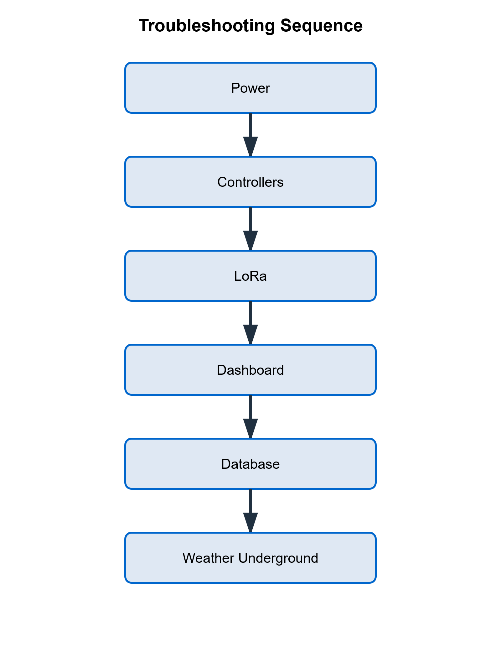

When diagnosing faults, begin with power verification and proceed sequentially through controllers, LoRa communications, dashboard operation, database services, and Weather Underground connectivity.

Figure 13-1. Troubleshooting Workflow
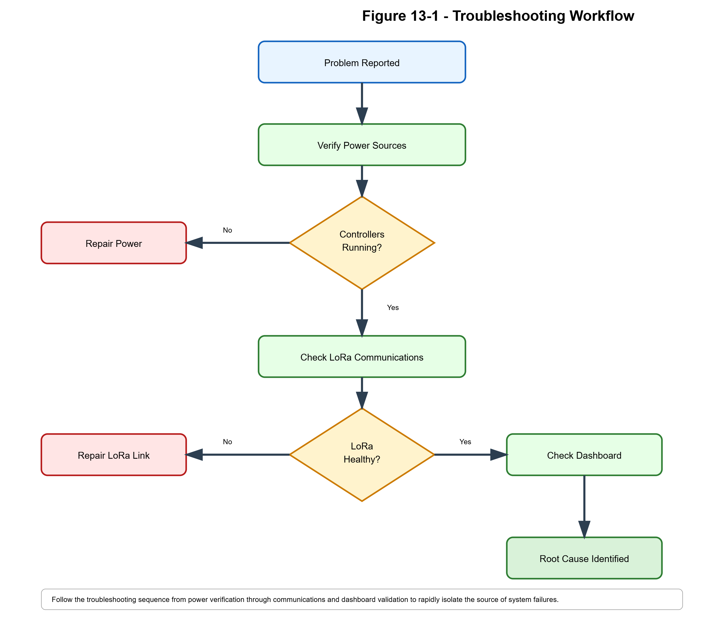
Recommended fault-isolation process for weather-station troubleshooting.

13.3 Ext NO Condition
Indicates stale outdoor communications.
Possible causes:
- Outdoor-node outage
- LoRa failure
- Antenna issue
- Power-system failure

13.4 Wind Data Missing
Potential causes:

Sensor Failure
LoRa Failure
GPIO Wiring Problem
Inspection should begin with communications verification.

13.5 Rainfall Problems
Possible causes:

Debris
Bucket Binding
Wiring Failure
Pull-Up Resistor Failure

13.6 Incorrect Time
Potential causes:

RTC Configuration
RTC Battery
RTC Failure

13.7 Dashboard Not Updating
Possible causes:

UART Failure
Gateway Failure
Parser Failure

13.8 Weather Underground Offline
Potential causes:

Internet Outage
Wi-Fi Failure
DNS Failure
Credential Issue

13.9 Database Upload Failure
If dashboard updates continue but database records stop:

Likely Server-Side Failure
rather than weather acquisition failure.

13.10 Failure-Isolation Matrix
Symptom | Likely Cause
Ext NO | Outdoor Communication Failure
No Wind | Sensor / LoRa Problem
Frozen Dashboard | Gateway Problem
OFFLINE Status | Internet Problem
Missing DB Records | Server Problem
Repeated Reboots | Power Problem

Section 14 – Preventive Maintenance
14.1 Purpose
Preventive maintenance maximizes system reliability and minimizes downtime.
Focus areas include:

Inspection
Cleaning
Verification
Testing
Documentation

14.2 Recommended Maintenance Schedule
Activity | Interval
Dashboard Review | Weekly
Outdoor Inspection | Monthly
Solar Cleaning | Monthly
Sensor Inspection | Quarterly
Battery Inspection | Semiannual
Full Functional Test | Annual

14.3 Weekly Tasks
Verify:

Dashboard Updating
Outdoor Uptime Increasing
Weather Underground ONLINE

14.4 Monthly Tasks
Inspect:

Mast
Enclosure
Solar Panel
Mounting Hardware
Clean the solar panel as required.

14.5 Quarterly Tasks
Inspect:

Wind Vane
Anemometer
Rain Gauge
Sensor Wiring
Verify proper operation of each component.

14.6 Semiannual Tasks
Inspect:

Battery
Charge Controller
Power Wiring
Verify all connections remain secure.

14.7 Annual Tasks
Perform a complete functional verification.
Verify:

Sensors
LoRa
Dashboard
Database
Weather Underground
all remain operational.

Figure 14-1. Annual Maintenance Verification Flow
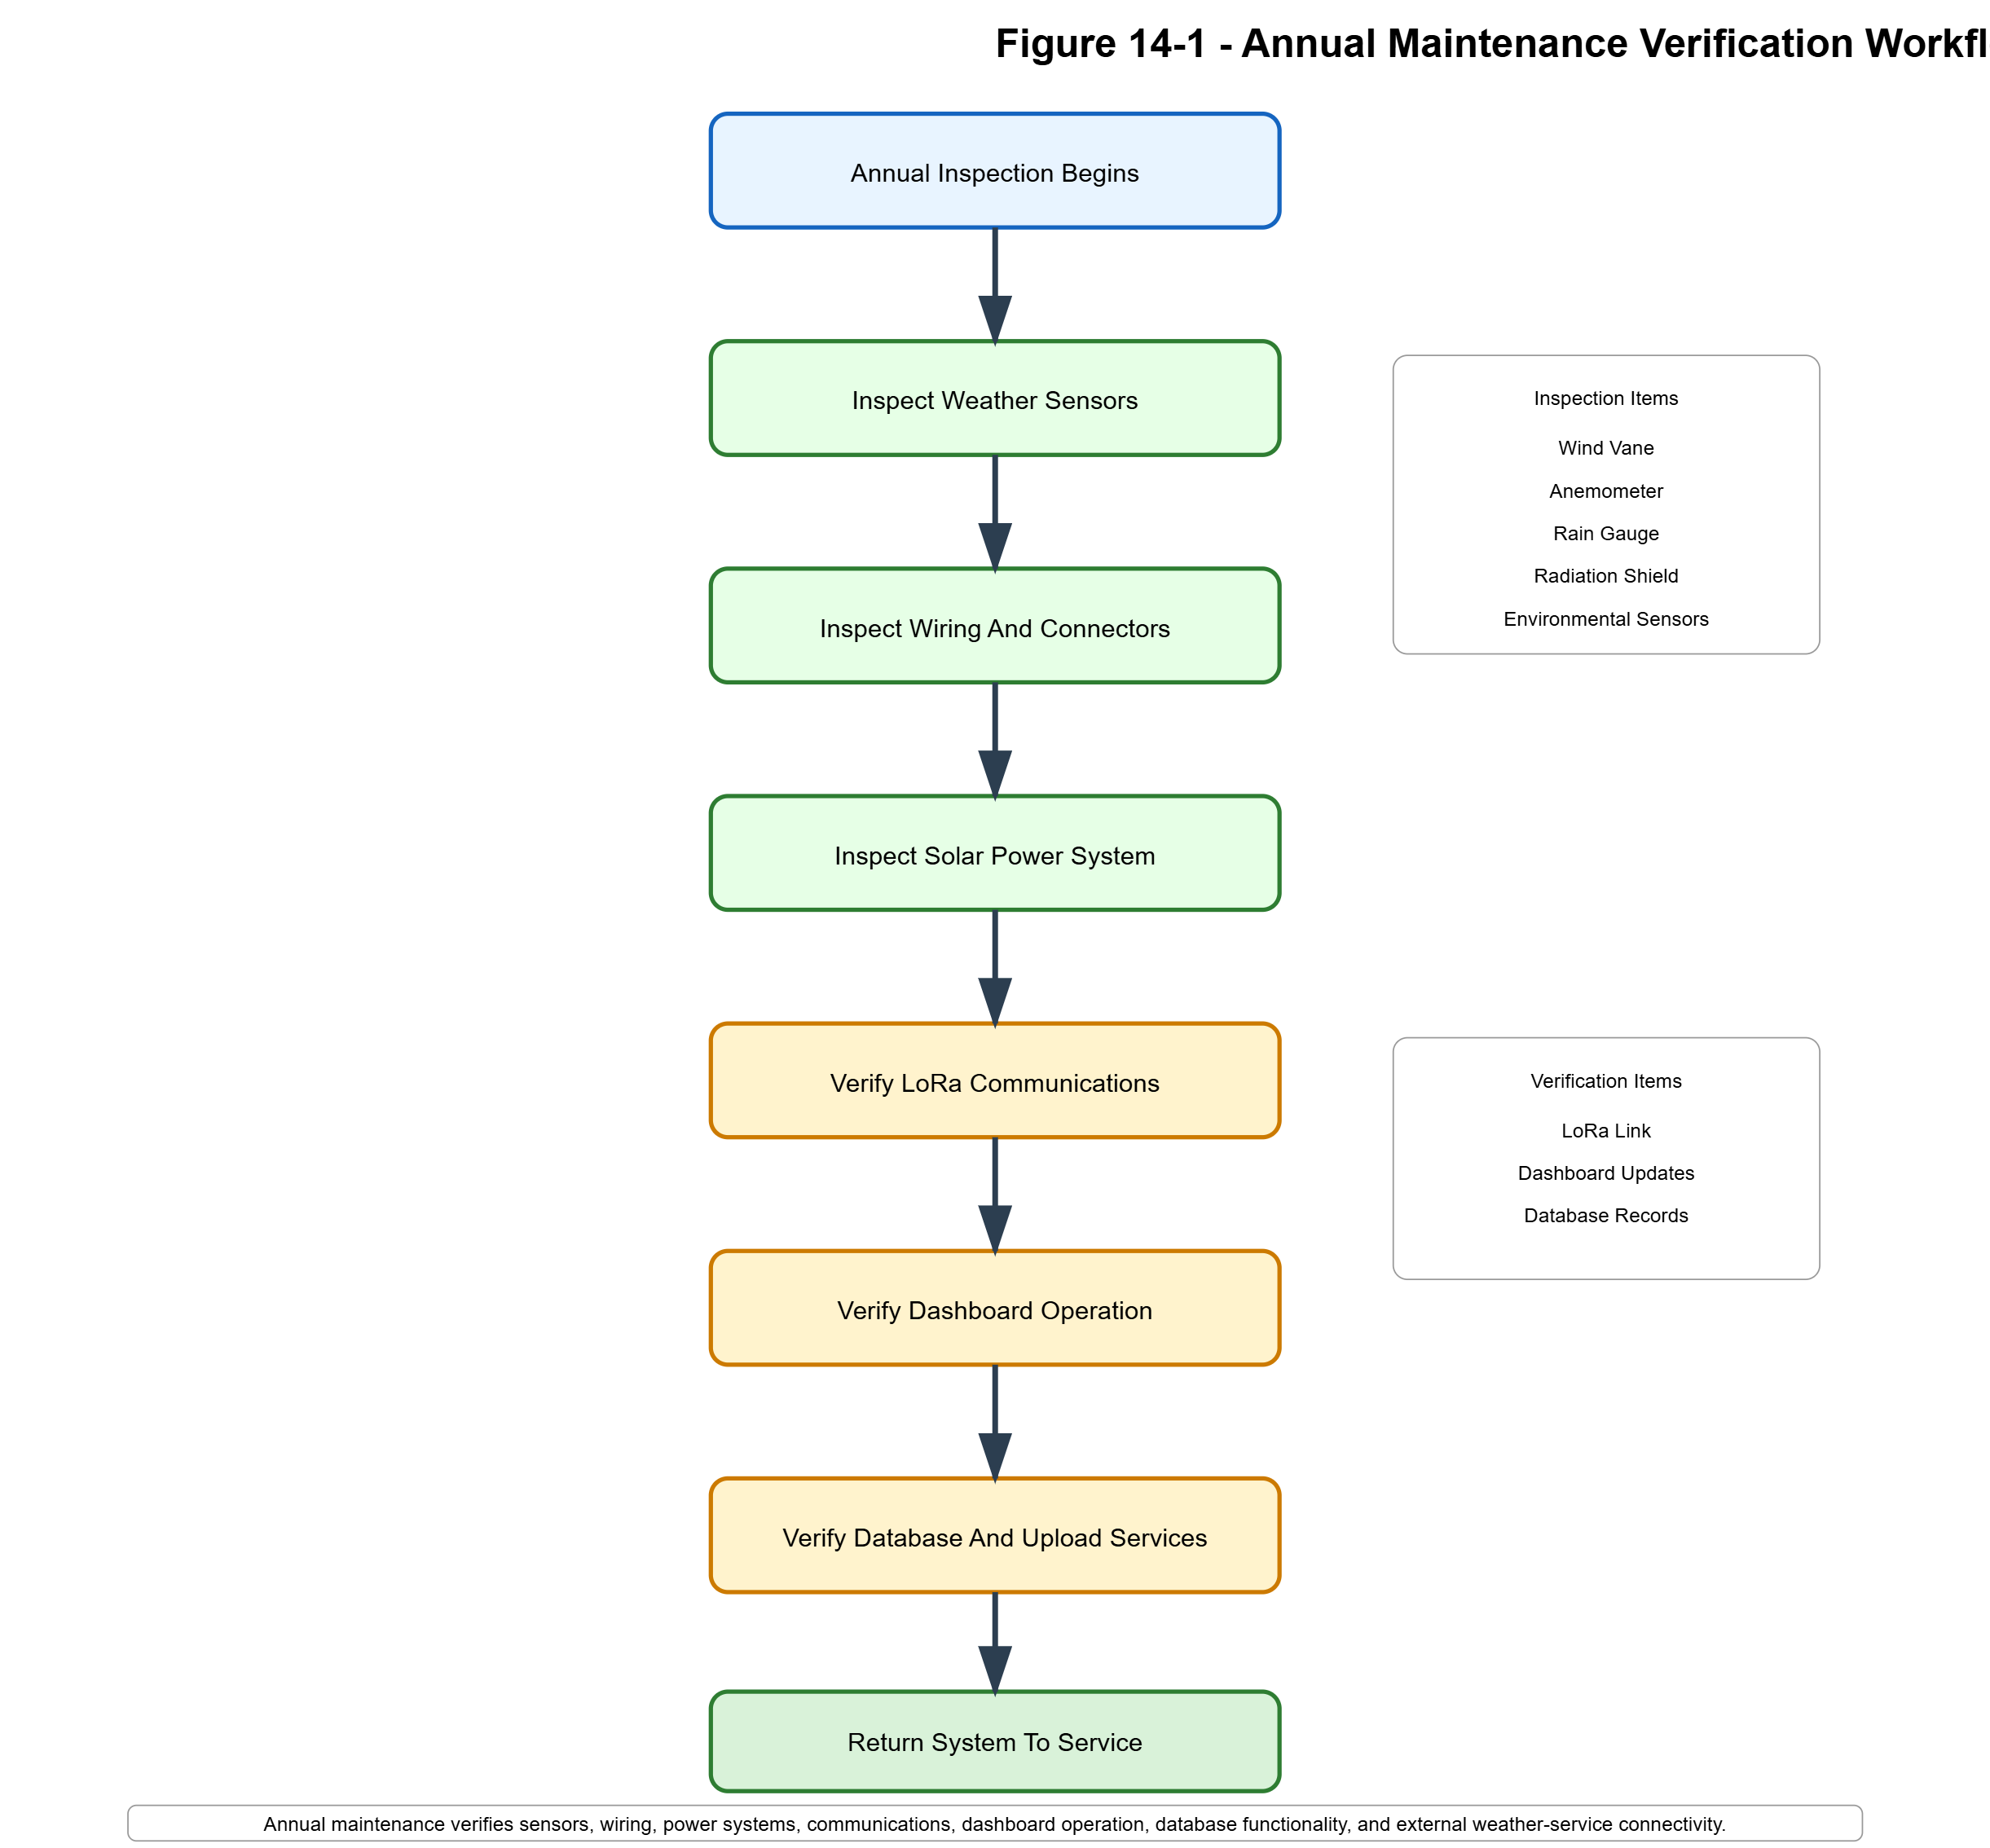
Annual maintenance verification sequence used to validate operation of all major system components.

14.8 Post-Storm Inspection
After severe weather:
Inspect:

Sensors
Pole
Enclosure
Solar Panel
Antenna
Cabling
and verify normal operation.

14.9 Service Log
A maintenance record should include:

Date
Technician
Findings
Corrective Actions
Firmware Version
Long-term records simplify support and system evolution.

Section 15 – Operations and Long-Term Support
15.1 Purpose
This section provides operational guidance that supplements the technical material presented throughout this manual. While previous sections focus on system architecture, firmware, communications, and hardware implementation, this section focuses on day-to-day operation, recovery procedures, preventive stewardship, and long-term maintenance.
The objective is to ensure that future maintenance personnel can successfully operate, troubleshoot, and preserve the Wireless Weather Station system even if the original designer is no longer available.

15.2 System Startup Procedure
Cold Start
After a complete power loss, the system should start in the following sequence:
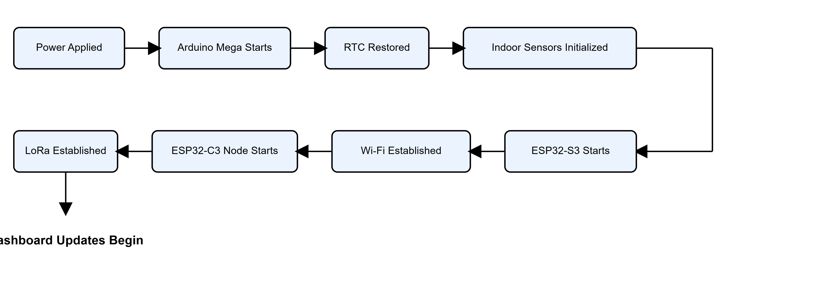 Figure 15-1. Cold Start Initialization Sequence
Normal startup should require no operator intervention.

Startup Verification Checklist
Verify:
- LCD active
- Date and time valid
- Ext OK displayed
- Outdoor uptime increasing
- Dashboard updating
- Weather Underground ONLINE
- Database records appearing

15.3 Normal Operations Checklist
The station is intended to operate continuously.
Arduino Mega
Verify:
- Display active
- Current weather displayed
- Button navigation functional
ESP32-C3 Outdoor Node
Verify:
- Outdoor uptime increasing
- Wind updates present
- Rain updates present
ESP32-S3 Gateway
Verify:
- Dashboard updating
- Database uploads active
- Weather Underground ONLINE

15.4 Recovery Procedures
Communications Failure Recovery
If outdoor communications stop:
- Observe Ext NO condition.
- Verify outdoor uptime.
- Allow automatic recovery.
- Observe STATUS requests.
- Observe REBOOT attempts.
- Verify uptime reset after recovery.
Dashboard Recovery
If dashboard updates stop:
- Verify Arduino Mega operation.
- Verify UART communications.
- Verify ESP32-S3 operation.
- Verify browser connectivity.
- Restart ESP32-S3 if necessary.
Internet Recovery
If uploads fail:
- Verify Wi-Fi connectivity.
- Verify local Internet access.
- Verify Weather Underground status.
- Verify database connectivity.
- Observe automatic recovery behavior.

15.5 Seasonal Inspection Recommendations
Spring
- Rain-gauge cleaning
- Wiring inspection
- Sensor inspection
Particular attention should be given to winter-weather damage.
Summer
- Solar-panel cleaning
- Radiation-shield inspection
- Temperature verification
Excessive contamination can affect temperature accuracy.
Fall
- Rain-gauge cleaning
- Leaf removal
- Sensor inspection
This period is particularly important for maintaining rainfall accuracy.
Winter
- Battery inspection
- Solar charging verification
- Enclosure-seal inspection
Cold-weather operation should be verified before severe weather arrives.

15.6 Documentation and Backup Strategy
The following records should be preserved throughout the life of the system:
Technical Documents
- Technical Manual
- User Manual
- Protocol Specifications
- Wiring Diagrams
Firmware Archives
- Arduino Mega firmware
- ESP32-S3 firmware
- ESP32-C3 firmware
All released versions should be archived.
Installation Records
- Installation photographs
- Wiring photographs
- Enclosure photographs
- Sensor alignment notes
These records significantly simplify future troubleshooting and upgrades.
Recommended Backup Schedule
Item | Recommended Frequency
Firmware | Before major changes
Technical Documentation | After each revision
Database | Weekly
Configuration Files | After modification
Historical weather data becomes increasingly valuable as the archive grows.

15.7 Spare Equipment Strategy
Recommended on-hand inventory:
Quantity | Item
1 | Arduino Mega
1 | ESP32-S3
1 | ESP32-C3
1 | LoRa Module
10 | RJ11/RJ12 Connectors
2 | Sensor Cables
1 | LiFePO4 Battery
Assorted | Resistors and wiring components
The objective is to enable rapid recovery from common hardware failures.

15.8 Long-Term Support Philosophy
The weather station was designed around three primary goals:
- Reliability
- Serviceability
- Expandability
Future modifications should preserve these principles whenever practical.
New features should not compromise:
- Existing weather acquisition
- Existing communications
- Existing recovery mechanisms
The preferred approach is evolutionary improvement rather than architecture replacement.

Appendices A–H
Reference Material, Asset Inventory, Change History, and Future Planning

Appendix A – GPIO and Signal Reference
A.1 Purpose
This appendix provides a consolidated reference for all controller GPIO assignments, communication interfaces, sensor connections, and signal paths used throughout the weather station.
The GPIO reference serves as the primary hardware reference for:
- Troubleshooting
- Firmware development
- Hardware expansion
- Maintenance
- System replication

A.2 Arduino Mega GPIO Assignments
User Interface
Pin | Function
A0 | LCD button ladder input
D10 | LCD backlight control

LoRa Communications
Pin | Function
D16 | LoRa TX
D17 | LoRa RX

ESP32-S3 Communications
Pin | Function
D18 | UART1 TX
D19 | UART1 RX

I²C Bus
Pin | Function
D20 | SDA
D21 | SCL

A.3 ESP32-S3 GPIO Assignments
GPIO | Function
GPIO18 | UART RX from Mega
GPIO17 | UART TX

A.4 ESP32-C3 GPIO Assignments
GPIO | Function
GPIO0 | Wind vane ADC
GPIO3 | Rain gauge
GPIO4 | LoRa RX
GPIO5 | LoRa TX
GPIO10 | Anemometer

A.5 Sensor Interface Summary
Indoor Sensors

SHT31-D
BMP280
DS3231
Communications:

I²C

Outdoor Sensors

Wind Vane
Anemometer
Rain Gauge
Communications:

ADC + Interrupt Inputs

A.6 Signal Path Summary
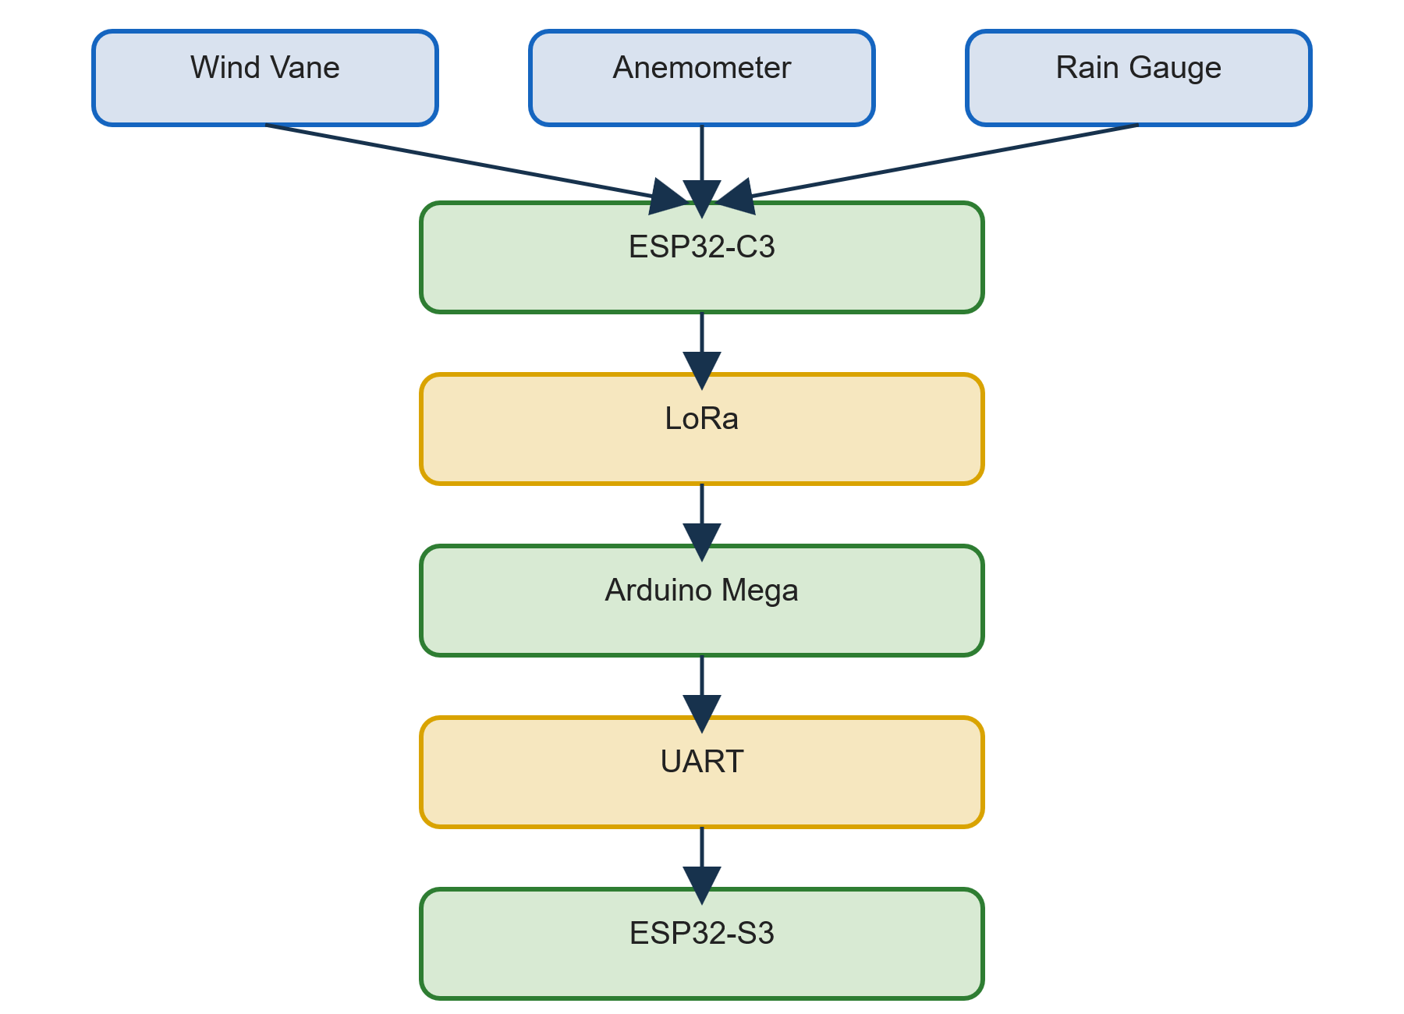

Appendix B – EEPROM Memory Map
B.1 Purpose
EEPROM storage preserves critical station information across power cycles.
Stored information includes:
- Environmental records
- Settings
- Reset information
- Calibration parameters

B.2 EEPROM Allocation
Address | Function
0 | Min Temperature
4 | Max Temperature
8 | Min Humidity
12 | Max Humidity
16 | Min Pressure
20 | Max Pressure
24 | Altitude
28–48 | Timestamp Records
500 | Reset Flag
520–523 | Last Reset Information

B.3 EEPROM Organization

Environmental Records
↓
Timestamps
↓
Configuration
↓
Recovery Information

B.4 Startup Recovery
Upon startup:
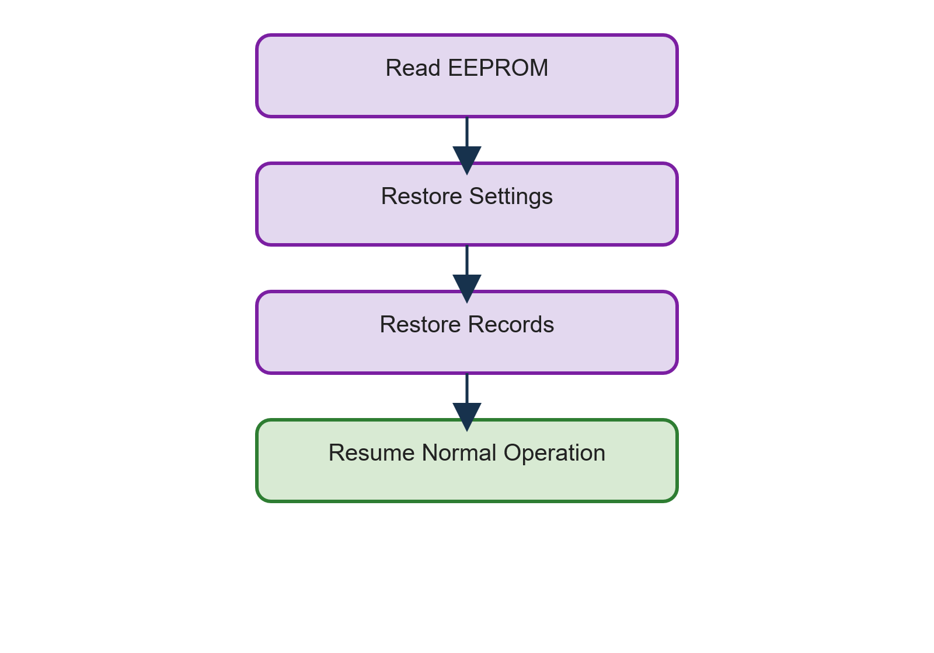

Appendix C – Communications Protocol Reference
C.1 Protocol Layers

Layer 1 LoRa
Layer 2 UART
Layer 3 HTTP

C.2 OUT Packet
Purpose
Primary outdoor telemetry packet.
Structure

<OUT>
WindSpeed,
WindGust,
Direction,
RainRate,
DailyRain,
RainTips,
Uptime
</OUT>

C.3 STATUS Protocol
Request

<STATUS?>
Response

<STATUS>

C.4 REBOOT Protocol
Request

<REBOOT>
Response

<REBOOTING>

C.5 UART Weather Packet
The Mega forwards:

Temperature
Humidity
Dew Point
Pressure
Wind Speed
Wind Direction
Rainfall
Outdoor Uptime
Date
Time
to the ESP32-S3.

C.6 Communications Timing
Activity | Interval
LoRa Telemetry | ~5 sec
UART Update | ~5 sec
Status Request | ~30 sec
Reboot Trigger | ~60 sec
Retry Count | 3

Appendix D – Database Field Dictionary
D.1 Temperature Fields
Field | Description
temp | Corrected temperature
rawtemp | Raw sensor reading
adjfactor | Applied adjustment

D.2 Moisture Fields
Field | Description
humidity | Relative humidity
dewpt | Dew point
moist | Moisture classification
dewpot | Dew-potential classification

D.3 Pressure Fields
Field | Description
presshpa | Pressure in hPa
pressinhg | Pressure in inches Hg

D.4 Wind Fields
Field | Description
winddir | Direction
windspd | Wind speed
windgust | Peak gust
windlast | Previous direction value

D.5 Rain Fields
Field | Description
rainrate | Current rain intensity
rainday | Daily rainfall
raintips | Bucket-tip count

D.6 Health Fields
Field | Description
outuptime | ESP32-C3 uptime
nextupl | Upload timer
lastconn | Last connection
WUstat | Weather Underground status

Appendix E – System Parts List (BOM)
E.1 Indoor Controller
Qty | Component
1 | Arduino Mega 2560
1 | ESP32-S3
1 | LCD Keypad Shield
1 | SHT31-D
1 | BMP280
1 | DS3231 RTC
1 | RYLR890 LoRa Module

E.2 Outdoor Node
Qty | Component
1 | ESP32-C3
1 | RYLR890 LoRa Module
1 | Wind Vane
1 | Anemometer
1 | Tipping-Bucket Rain Gauge

E.3 Solar Power System
Qty | Component
1 | Newpowa NPA5S-12J Solar Panel
1 | SOLPERK 8A Charge Controller
1 | 12V LiFePO4 Battery

E.4 Spare Parts Inventory
Recommended stock:

ESP32-C3
ESP32-S3
LoRa Module
SHT31-D
BMP280
DS3231
RJ11/RJ12 Connectors
10K and 12K Resistors
Sensor Cable

Appendix F – Source File Inventory
F.1 Firmware Files
Arduino Mega

Min_Max_Temp_with_LoRa.ino
Purpose:

Main Weather Controller

ESP32-S3

ESP32_S3_Inside_Station.ino
Purpose:

Gateway / Dashboard

ESP32-C3

ESP32_C3_outside_station.ino
Purpose:

Outdoor Telemetry Node

F.2 PHP Files
weatherdb.php
Purpose:

Database Upload Handler

index.php
Purpose:

Dashboard Interface

dewpoint.php
Purpose:

Dew Point Calculations

F.3 Engineering References

New RJ11 and Wireless Connections.txt
Power Supply Info.txt
LoRa Output.txt

Appendix G – Engineering Notes and Design Rationale
G.1 Development Progression
The weather station evolved through several major phases:

Single Controller
↓
LoRa Communications
↓
Outdoor Controller
↓
ESP32-S3 Gateway
↓
Database Storage
↓
Web Dashboard
↓
Solar Power System

G.2 Major Enhancements
Distributed Controller Architecture
Benefits:
- Reduced software complexity
- Better fault isolation
- Improved maintainability

LoRa Communications
Benefits:
- Reduced wiring
- Improved deployment flexibility
- Better sensor placement

Remote Reboot Capability
Benefits:
- Reduced service visits
- Improved uptime
- Automated recovery

Database Archiving
Benefits:
- Historical records
- Trend analysis
- Reporting capability

G.3 Why a Three-Controller Architecture Was Selected
The weather station could have been implemented using a single microcontroller.
That approach was ultimately rejected because it would have created a controller responsible for:
- Weather measurements
- User interface
- Database communications
- Dashboard hosting
- LoRa communications
- Internet communications
By distributing responsibilities across three processors, each subsystem remains relatively independent.
Arduino Mega
Responsible for:
- Weather Logic
- LCD Interface
- RTC
- EEPROM
- Recovery Management
ESP32-C3
Responsible for:
- Outdoor Data Acquisition
- LoRa Communications
- Rain Processing
- Wind Processing
ESP32-S3
Responsible for:
- Dashboard
- Wi-Fi
- Database Uploads
- Weather Underground Uploads
This separation significantly simplifies maintenance and troubleshooting.

G.4 Why LoRa Was Selected
Several wireless technologies were considered.
Wi-Fi
Advantages:
- High Throughput
- Easy Network Integration
Disadvantages:
- Higher Power Consumption
- Outdoor Coverage Challenges
Bluetooth
Advantages:
- Low Cost
- Simple Hardware
Disadvantages:
- Limited Range
LoRa
Advantages:
- Excellent Range
- Low Power Consumption
- Reliable Outdoor Operation
- Simple Deployment
LoRa was selected because it provided the best combination of range and reliability for the outdoor sensor node.

G.5 Why Solar Power Was Adopted
The original concept assumed permanent wired power.
During development it became apparent that outdoor sensor placement and wiring flexibility would improve significantly if the outdoor node became self-powered.
Benefits achieved:
- No power cable
- Flexible installation
- Reduced trenching
- Improved placement options

G.6 Why Outdoor Uptime Was Added
Outdoor uptime was not part of the original design.
Troubleshooting revealed that determining whether the outdoor node had rebooted was often difficult.
The uptime counter was introduced to provide visibility into:
- Unexpected Resets
- Power Problems
- Recovery Success
- Communications Health
It became one of the most valuable diagnostic metrics in the entire system.

G.7 Why Remote Reboot Was Added
Field failures occasionally required access to the outdoor node.
Because the node can be mounted outdoors and operate on solar power, physical access is less convenient than access to indoor equipment.
The remote reboot protocol was created so that:
- Communications Failures
- Software Lockups
- Temporary Faults
could often be recovered without a service visit.

G.8 Why a 12K Resistor Was Selected for the Wind Vane
Wind-Vane Signal Conditioning
The wind vane is connected to ESP32-C3 GPIO0 through a 12K pull-up resistor to the 3.3V rail.
The resistor forms a voltage divider with the vane's internal resistor network, allowing the ADC to distinguish individual wind-direction states.
A 12K pull-up resistor was selected through empirical testing. The value produced reliable separation between wind-direction ADC states while maintaining stable measurements. Testing showed that a 10K pull-up resistor did not provide sufficient separation between all vane positions.

G.9 Reliability Philosophy
The station was designed around a simple principle: Weather acquisition should continue whenever possible.

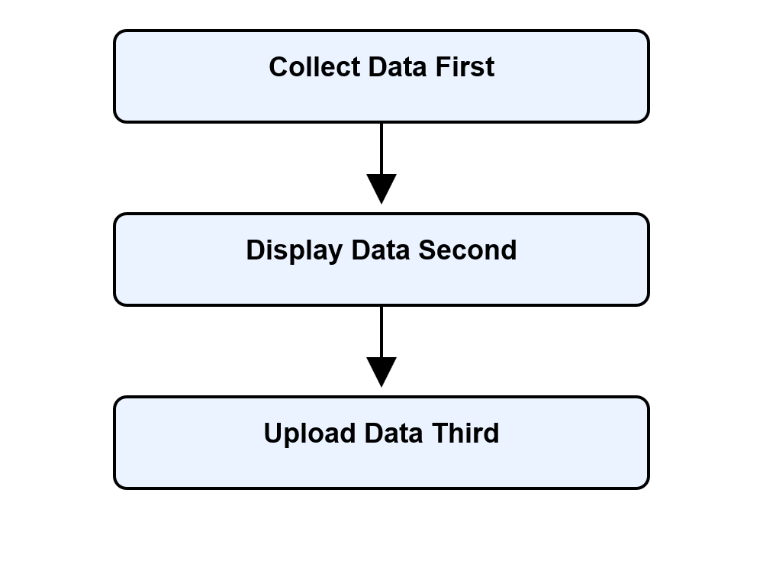
Figure G-1. Reliability Philosophy Hierarchy
Failures in:
- Internet Connectivity
- Database Services
- Dashboard Services
should not prevent weather collection.
This principle strongly influenced the final architecture.

G.10 Design Principles
The weather station follows the principles below.
Simplicity
Prefer understandable solutions over sophisticated solutions.
Recoverability
Subsystems should recover automatically whenever practical.
Visibility
Failures should be obvious.
Documentation
Critical behaviors should be documented.
Expandability
Future sensors should be easy to add.

G.11 Long-Term Support Objectives
The project was designed with an anticipated service life measured in years rather than months.
Long-term goals include:
- Minimal Maintenance
- Predictable Operation
- Simple Repair
- Incremental Enhancement
The technical manual exists partly to support these objectives.

Appendix H – Future Enhancements Roadmap
H.1 Power Monitoring
Future capabilities:

Battery Voltage
Charge Current
Solar Voltage
Battery Health

H.2 Environmental Expansion
Potential additions:

Outdoor Humidity
UV Index
Solar Radiation
Air Quality

H.3 Dashboard Improvements
Potential features:

Historical Graphs
Trend Analysis
Interactive Reporting
Mobile Optimization

H.4 Communications Enhancements
Potential features:

Packet Statistics
Reliability Metrics
Signal-Quality Tracking
Advanced Diagnostics

H.5 Remote Administration
Future possibilities:

Remote Configuration
Remote Calibration
Remote Firmware Updates

H.6 Version 2.0 Vision
Potential Version 2.0 capabilities:

Solar Telemetry
Battery Telemetry
Historical Charting
Advanced Forecasting
Remote Updates
Additional Sensors
Enhanced Analytics
while maintaining the proven architecture:

Arduino Mega
ESP32-S3 Gateway
ESP32-C3 Outdoor Node
LoRa Communications
Dashboard
Database

